

American International University-Bangladesh (AIUB)
Faculty of Science and Technology

Patient-Similarity Graph Neural Networks for PCOS Detection from Routine Clinical Data

Mostafa Galib (22-49791-3)
Tahmid Mahbub Tonmoy (22-49783-3)
Syed Mostafa Tahsinul Islam (22-49843-3)
Meherunnesa Monami (22-49824-3)

A Thesis submitted for the degree of Bachelor of Science (BSc) in
Computer Science and Engineering (CSE) at
American International University Bangladesh (AIUB
Faculty of Science and Technology (FST)

Summer 2025-2026 Semester
Submission Date: July, 2026

Declaration

This thesis is composed of our original work, and contains no material previously published or written by another person except where due reference has been made in the text. We have clearly stated the contribution of others to our thesis as a whole, including statistical assistance, survey design, data analysis, significant technical procedures, professional editorial advice, financial and any other original research work used or reported in our thesis. The content of our thesis is the result of work we have carried out since the commencement of the Thesis.

We acknowledge that copyright of all material contained in my thesis resides with the copyright holder(s) of that material. Where appropriate we have obtained copyright permission from the copyright holder to reproduce material in this thesis and have sought permission from co-authors for any jointly authored works included in the thesis.

_______________________________  Mostafa Galib  22-49791-3  Department of Computer Science | _______________________________  Tahmid Mahbub Tonmoy  22-49783-3  Department of Computer Science
_______________________________  Syed Mostafa Tahsinul Islam  22-49843-3  Department of Computer Science | _______________________________  Meherunnesa Monami  22-49824-3  Department of Computer Science

Approval

The thesis titled “Patient-Similarity Graph Neural Networks for PCOS Detection from Routine Clinical Data” has been submitted to the following respected members of the board of examiners of the department of computer science in partial fulfilment of the requirements for the degree of Bachelor of Science in Computer Science and Engineering on 6 August 2026 and has been accepted as satisfactory.

Mirza Asif Mahmud  Lecturer & Supervisor  Department of Computer Science  American International University-Bangladesh |  |  | S M Abdullah Shafi  Lecturer & External  Department of Computer Science  American International University-Bangladesh
Prof. Dr. Muhammad Firoz Mridha
Professor & Head (UG)
Department of Computer Science
American International University-Bangladesh

Prof. Dr. Khandaker Tabin Hasan  Professor & Associate Dean  Faculty of Science and Technology  American International University-Bangladesh |  |  | Prof. Dr. Dip Nandi  Professor & Dean  Faculty of Science and Technology  American International University-Bangladesh

Acknowledgement

We would like to express our sincere gratitude to everyone who supported me through the completion of this thesis.

Above all, we are deeply grateful to our supervisor, Mirza Asif Mahmud, Lecturer, Department of Computer Science, American International University–Bangladesh (AIUB). His guidance, thoughtful feedback, and unwavering encouragement shaped this work at every stage, from refining the research questions to improving the final manuscript. We sincerely appreciate the time and care he devoted to reviewing our methodology and findings, and for encouraging us to pursue a more rigorous and honest approach to this research.

We would also like to express our sincere appreciation to our mentor, Dipta Justin Gomez, Assistant Professor, Department of Computer Science, American International University–Bangladesh (AIUB). His valuable advice, encouragement, and willingness to share his knowledge provided invaluable guidance throughout this research and greatly contributed to its completion.

Lastly, we are incredibly grateful to our families, friends, and fellow team members for their unwavering encouragement, patience and collaborative spirit throughout this journey.

Table of Content

Declaration ii
Approval iii
Acknowledgement iv
Table of Content v
List of Figures viii
List of Tables ix
List of Abbreviations x
Abstract xii
Keywords xiii
Chapter 1 14
Introduction 14
1.1 Introduction 14
1.2 Problem Statement 15
1.3 Problem Background 15
1.4 Research Objectives 16
1.5 Research Questions 17
1.6 Motivations 17
1.7 Flow of Research 18
1.8 Significance of the Research 19
1.9 Research Contribution 19
1.10 Thesis Organization 20
1.11 Summary 20
Chapter 2 21
Literature Review 21
2.1 Introduction 21
2.2 Literature Review 21
2.2.1 The Clinical Problem and the Motivation For Computational Approaches 21
2.2.2 Supervised Machine Learning For PCOS Detection on Clinical Tabular Data 22
2.2.3 Deep Learning, Imaging and Multimodal Approaches 24
2.2.4 Scope boundary: PCOS Heterogeneity and Phenotypic Subtyping 25
2.2.5 Graph Neural Networks 26
2.2.6 Graph Neural Networks on Tabular Data 27
2.2.7 Graph Neural Networks on Patient-Similarity Graphs 28
2.2.8 Graph Methods in PCOS to Date 29
2.2.9 Comparative Summary 30
2.3 Problem Analysis 31
2.4 Summary 32
Chapter 3 34
Proposed Model 34
3.1 Introduction 34
3.2 Feasibility Analysis 34
3.3 Requirement Analysis 35
3.4 Research Methodology 36
3.4.1 Dataset and Cohort Composition 36
3.4.2 Data Cleaning and Encoding 36
3.4.3 Data Partitioning and the Sealed-Test Protocol 38
3.4.4 Patient-Similarity Graph Construction 39
3.4.5 Structural Embedding 40
3.4.6 Class-Imbalance Handling 40
3.4.7 Evaluation Protocol and Metrics 41
3.4.8 Statistical Significance Layer 41
3.5 System Design and Architecture 43
3.5.1 Message-Passing Architectures 43
3.5.2 Design Disclosure 44
3.6 Implementation and Simulation 45
3.6.1 The Fold-Local Training Loop 45
3.6.2 The Sealed-Test Protocol 45
3.6.3 The Determinism Check 46
3.6.4 The Three Experimental Arms 46
3.7 Tools and Technologies Used 47
3.8 Summary 48
Chapter 4 49
Implementation and Testing 49
4.1 Introduction 49
4.2 System Setup and Environment 49
4.3 Implementation of the System 50
4.4 Evaluation and Testing 51
4.5 Results and Discussion 51
4.5.1 RQ1: Can a Patient-Similarity GNN Detect PCOS From Routine Clinical Data? 51
4.5.2 RQ2: Which Architecture is Best Suited to a Patient-Similarity Graph, and are the Differences Real? 55
4.5.2 RQ3: Does Feature Selection Improve Detection, or Only Parsimony? 59
4.5.4 RQ4: Does Hyperparameter Optimization Improve on Well-Chosen Defaults? 64
4.5.5 RQ5: What Does the Graph Add Over Standard Tabular Classifiers? 67
4.5.6 Discrimination Against Chance 69
4.6 Summary 69
Chapter 5 71
Standards, Constraints and Milestones 71
5.1 Standards and Compliance 71
5.2 Sustainability Considerations 71
5.3 Societal Impact 72
5.4 Ethical Considerations 72
5.5 Security and Privacy Considerations 72
5.6 Design Constraints and Component Constraints 73
5.7 Data Constraints and Computational Constraints 73
5.8 Budget Constraints 74
5.9 Task Breakdown and Project Timeline 75
5.10 Milestones and Deliverables 76
5.11 Gantt Chart 76
5.12 Summary 77
Chapter 6 78
Conclusion 78
6.1 Summary of the Work Done 78
6.2 Key Contributions 79
6.3 Limitations of the Study 80
6.4 Future Work 81
References 82
Appendix 89

List of Figures

Figure 3.1: | Overall Pipeline for PCOS Detection Using the Patient-Similarity Graph Neural Network Framework | 40
Figure 4.1: | Final Architecture Ranking by MCC on the sealed Test | 54
Figure 4.2: | GraphSAGE Confusion Matrix (Sealed Test) | 54
Figure 4.3: | GraphSAGE ROC and Precision-Recall Curves (Sealed Test) | 54
Figure 4.4: | DET Curve for GraphSAGE | 55
Figure 4.5: | Lift and Cumulative-Gains Curves for GraphSAGE | 55
Figure 4.6: | Precision, Recall and F1 as a Function of the Decision Threshold, GraphSAGE | 55
Figure 4.7: | Training-Loss Curve for the Final GraphSAGE Model | 56
Figure 4.8: | t-SNE projection of the structural embeddings of the full graph | 56
Figure 4.9: | ROC Overlay for the Five Architectures | 58
Figure 4.10: | Precision-Recall Overlay for the Five Architectures | 59
Figure 4.11: | Metric Comparison Across the Five Architectures | 59
Figure 4.12: | GIN Confusion Matrix | 59
Figure 4.13: | GraphSAGE training loss and validation AUROC across epochs, mean and standard-deviation band over the ten cross-validation folds | 60
Figure 4.14: | Per-fold metric variation for GraphSAGE | 60
Figure 4.15: | MCC Ranking of the Nine Sealed-Test Configurations | 63
Figure 4.16: | Confusion Matrices for All Nine Configurations (Sealed Test) | 64
Figure 4.17: | ROC Overlay Across the Nine Configurations | 64
Figure 4.18: | MI subset: ROC, precision-recall and DET curves | 65
Figure 4.19: | Calibration curve for MI_DEFAULT on the sealed test | 65
Figure 4.20: | Training-Loss Curves for All Nine Configurations | 67
Figure 5.1: | Project Gantt chart | 78

List of Tables

Table 2.1 | Comparative summary of the most directly relevant literature | 30
Table 3.1 | Cohort Composition and Data Partition | 36
Table 3.2 | Feature Inventory (48 Predictors) | 37
Table 3.3 | Data Cleaning Actions | 37
Table 3.4 | Pipeline Configuration | 42
Table 3.5 | Architecture Specifications | 43
Table 3.6 | Computational Environment | 48
Table 4.1 | Sealed-Test Metrics For the Five Architectures, Ranked by MCC | 52
Table 4.2 | Confusion-Matrix Components On the Sealed Test | 52
Table 4.3 | Ten-fold cross-validation on the training pool (mean +/- standard deviation) | 56
Table 4.10 | Family 1 - GraphSAGE Against the Alternative Architectures | 56
Table 4.11 | Feature Subsets Carried into Sealed-Test Evaluation | 60
Table 4.5 | Sealed-Test Results for the Nine Configurations | 60
Table 4.6 | Feature-selection effect relative to the 48-feature baseline (descriptive; see Table 4.11 for the inferential result). | 61
Table 4.11 | Family 2 - the all-feature baseline against the feature-selected configurations | 61
Table 4.8 | Optuna optima per feature subset. The inner CV-MCC column is the search fitness surface, not a performance estimate. | 65
Table 4.7 | Effect of regime-aligned hyperparameter optimization on the sealed test  (Positive delta favors tuning) | 65
Table 4.9 | Non-graph baselines on the identical sealed test, with GraphSAGE for reference | 67
Table 4.12 | Fisher’s Exact Test of Single-Model Discrimination Against Chance | 69

List of Abbreviations

CS | Computer Science
CSE | Computer Science and Engineering
AMH | Anti-Müllerian Hormone
AUPRC | Area Under the Precision–Recall Curve
AUROC | Area Under the Receiver Operating Characteristic Curve
BMI | Body Mass Index
CV | Cross-Validation
DET | Detection Error Trade-off
DHEAS | Dehydroepiandrosterone Sulphate
EHR | Electronic Health Record
FN | False Negative
FP | False Positive
FSH | Follicle-Stimulating Hormone
GAT | Graph Attention Network
GCN | Graph Convolutional Network
GIN | Graph Isomorphism Network
GNN | Graph Neural Network
GPU | Graphics Processing Unit
HHO | Harris Hawks Optimization
k-NN | k-Nearest Neighbors
LH | Luteinizing Hormone
MCC | Matthews Correlation Coefficient
MI | Mutual Information
ML | Machine Learning
MLP | Multilayer Perceptron
MPNN | Message-Passing Neural Network
PCOS | Polycystic Ovary Syndrome
PR | Precision–Recall
PSO | Particle Swarm Optimization
RBF | Radial Basis Function
RBS | Random Blood Sugar
RF | Random Forest
ROC | Receiver Operating Characteristic
SHBG | Sex-Hormone-Binding Globulin
SMOTE | Synthetic Minority Over-sampling Technique
SVM | Support Vector Machine
TN | True Negative
TP | True Positive
TPE | Tree-structured Parzen Estimator
TSH | Thyroid-Stimulating Hormone
t-SNE | t-distributed Stochastic Neighbor Embedding
WHR | Waist–Hip Ratio
XGBoost | Extreme Gradient Boosting

Abstract

Polycystic ovary syndrome (PCOS) affects an estimated 10–13% of women of reproductive age worldwide, making it one of the most common endocrine disorders in this population. PCOS affects a vast number of individuals globally, yet many patients still remain undiagnosed. Particularly in areas where access to specialized endocrine cares is limited, the rate is higher. Machine learning algorithms have been heavily used for PCOS detection. But most existing approaches depend on representing patients as independent feature vector. As a result, these models miss out on valuable diagnostic information provided by the similarities and relationships among patients. This study proposes and evaluates an alternative graph-based framework in which patients are represented as nodes within a similarity graph constructed from routine clinical data. In this approach, the PCOS detection task is reformed as a node classification problem, enabling the model to take advantage of inter-patient relationships during prediction. The proposed framework was evaluated using a cohort of 541 patients characterized by 48 routinely collected clinical, biochemical, anthropometric, and ultrasound features. Each patient was connected to her ten nearest neighbors by cosine similarity and represented by her standardized clinical vector concatenated with a 64-dimensional structural embedding learned from random walks over the graph. Five message-passing graph neural architectures were benchmarked under an identical pipeline. They are Graph Convolutional Network (GCN), Graph Attention Network (GAT), GraphSAGE, the Message-Passing Neural Network (MPNN) and Graph Isomorphism Network (GIN). To ensure an unbiased evaluation, a test set consisting of 109 patients was reserved before starting model development and remained untouched until the final assessment of each configuration. Furthermore, every data-dependent component, including feature scaling, graph construction, structural embedding generation, synthetic minority oversampling (SMOTE), feature selection, and hyperparameter optimization was derived only from the training data and reconstructed independently within each cross-validation fold to eliminate information leakage. Finally, statistical significance tests were performed using paired comparisons to validate the observed differences among competing models. Among the evaluated models, GraphSAGE achieved the best overall performance on the sealed test, with a Matthews correlation coefficient (MCC) of 0.8110, an AUROC of 0.9486 and an accuracy of 0.9174 or 91.74%. The model correctly identified 30 of 36 PCOS-positive patients with 3 false-positives. It significantly outperformed the Graph Isomorphism Network (GIN) but was not statistically separable from the remaining three architectures. Feature selection based on mutual information (MI) reproduced the full-feature result using 20 of 48 predictors. There was a parsimony gain rather than a performance gain, and hyperparameter optimization failed to improve upon default settings. When evaluated on the same test partition, the proposed framework achieved performance comparable to that of established tabular machine-learning models, including Random Forest, Logistic Regression, and Gradient Boosting. These findings support three main conclusions. Clinically, PCOS can be identified with useful discrimination from markers obtained during a routine gynecological examination, without relying on specialized assays whose limited availability often delay diagnosis in resource-constrained environments. Moreover, the required feature set can be reduced from 48 measurements to 20 without any measurable loss. Methodologically, the leakage-controlled evaluation protocol demonstrates that the benefits from the feature selection and hyperparameter optimization do not persist when assessed on previously unseen patients. This indicates that performance derives by the data representation and the evaluation protocol rather than from tuning. Finally, the study highlights the evidential limitations of a cohort of this size. It can be seen that a difference of 0.12 in Matthew’s correlation coefficient (MCC) between two architectures could not be distinguished from sampling variability in a test set of 109 patients, establishing that performance improvements reported on similarly sized cohorts should be interpreted with caution.

Keywords
polycystic ovary syndrome; graph neural network; patient-similarity graph; graphsage; clinical decision support; tabular data; node classification; feature selection; sealed-test evaluation; medical machine learning

Chapter 1

Introduction

Introduction
Polycystic ovary syndrome (PCOS) is one of the most prevalent endocrine disorders affecting women of reproductive age, with an estimated prevalence of approximately 10-13%, depending on the diagnostic criteria applied [1]. It is a heterogeneous disorder, by varying combinations of ovulatory dysfunction, clinical or biochemical hyperandrogenism, and polycystic ovarian morphology. Beyond its reproductive manifestations, PCOS is associated with an increased risk of insulin resistance, metabolic syndrome, type 2 diabetes, cardiovascular disease, and adverse psychological outcomes are all elevated in affected women [2]. Despite the high prevalence of PCOS, diagnosis is delayed in many situations. That leaves a large proportion of affected women remain undiagnosed [3]. The main reason of the delay in diagnosis is often structural limitations rather than a lack of clinical knowledge. In current diagnostic guidelines, a definitive diagnosis requires a multi-step evaluation interpreted by a specialist including clinical evaluation, biochemical testing, and transvaginal ultrasonography. Diagnosis can be easily disrupted in healthcare places with limited endocrine laboratory facilities, restricted access to specialists, or where patients present to general practitioners with symptoms that appear unremarkable when considered individually. As a result, many cases of PCOS remain undiagnosed, particularly in populations with limited access to long term healthcare and management of its metabolic complications.
This study approaches the problem from this exact perspective. It investigates whether the information already available from a routine gynecological workup: history, anthropometry, ordinary bloodwork and ultrasound is sufficient to support automated detection of PCOS and proposes a graph neural network framework to exploit this information. The central idea is that patients are not statistically independent observations, a woman whose clinical profile closely resembles that of several diagnosed patients is more likely to have PCOS, and a model capable of capturing these similarities can utilize information that would otherwise be unavailable to models treating each patient independently.

Problem Statement
Machine-learning models for PCOS detection are typically trained on tabular clinical data, where each patient is treated as an independent observation. This approach discards a source of evidence that clinicians rely on, which is the similarity between a presenting patient and previously diagnosed ones. Graph neural networks can capture these relationships, but clinical tabular data have no natural relational structure, so no patient graph exists to learn from. The problem is made worse by evaluation practices commonly used on the small cohorts typical of this field. These include preprocessing across the train–test split, failing to report statistical uncertainty, and omitting baseline comparisons, all of which make published performance difficult to trust. This is why it is unclear whether a patient-similarity graph built from routine clinical features can support defensible PCOS detection.

Problem Background
The study's clinical background focuses on the difficulties of PCOS. Since the syndrome is defined by a combination of diagnostic criteria rather than a single biomarker, and its presentation varies among patients, no individual measurement is sufficient for a definitive diagnosis. Machine learning is well suited for this type of problems, because the discriminative information is distributed across multiple weakly informative variables. This allows a model to integrate them more consistently than an unaided clinician working under time constraints. This study builds on recent advances in applying deep learning to non-Euclidean data. Graph neural networks operate through a message-passing mechanism, in which the representation of each node is iteratively updated by aggregating information from its neighboring nodes. As this process continues, a node’s embedding progressively captures information from an expanding neighborhood [2], [4]. This approach has shown strong performance in domains with inherent relational structures, such as molecular graphs, citation networks, and social networks, and has more recently been adopted in the medical field, where patient-similarity graphs are used to model disease progression and support diagnosis by using the relational structure within the patient cohort. Applying this model to PCOS requires the graph to be constructed rather than directly observed. In this approach, patients are first represented as nodes, with edges that connects patients who have similar clinical profiles. This transforms PCOS detection into a node-classification task on the induced graph. The graph construction process itself is a modelling decision with important implications, such as the choice of similarity metric, neighborhood size, and whether the graph is built before or after data partitioning can directly affect the validity of the results. It is also at this stage that information leakage can occur if the graph is not constructed carefully. The evaluative background of this study shows the current reporting practices in applied clinical machine learning. Small cohort sizes, the absence of external validation, and preprocessing performed on the entire dataset before data splitting are common across the literature. As a result, reported accuracy is often very high, comparisons between studies become difficult to interpret, and it remains unclear whether the reported performance improvements are genuine.

Research Objectives
- To construct a patient-similarity graph from routine clinical tabular data using cosine similarity on standardized features under a k-nearest-neighbor framework, without using the diagnostic label at any stage of graph construction.
- To develop a graph neural network framework in which each patient is represented by the combination of clinical measurements and a structural embedding that captures her position within the patient-similarity graph.
- To benchmark five message-passing graph neural network architectures GCN, GAT, GraphSAGE, MPNN and GIN, using the same experimental pipeline, ensuring that any observed performance differences arise from the architectures themselves rather than variations in preprocessing.
- To investigate whether feature selection, using mutual information and methodology, enhance detection performance or primarily reduce the size of the input panel.
- To assess whether hyperparameter optimization, performed in accordance with the intended deployment training regime, provides improvements over carefully selected default settings.
- To compare the proposed framework with strong non-graph tabular classifiers using the same data partition and assess whether the graph-based representation improves predictive performance.
- To evaluate all comparative results using paired statistical tests with appropriate correction for multiple comparisons, allowing observed performance differences to be distinguished from sampling variability.

Research Questions
- RQ1: Can a patient-similarity graph neural network detect PCOS from routine clinical tabular data with performance suitable for screening, while using a leakage-controlled sealed-test evaluation protocol?
- RQ2: Which message-passing architecture performs best on a k-nearest-neighbor patient-similarity graph constructed from routine clinical features, and are any performance differences between architectures statistically significant?
- RQ3: Does feature selection improve PCOS detection performance, or can similar performance be achieved with a smaller set of input features?
- RQ4: Does hyperparameter optimization, conducted under the same training regime used for model deployment, provide any improvement over carefully selected default hyperparameter settings?
- RQ5: What additional contribution does the graph-based representation provide compared with strong non-graph tabular classifiers evaluated on the same data partition?

Motivations
PCOS is one of the most common endocrine disorders affecting women and is associated with lifelong reproductive, metabolic and cardiovascular consequences. But in healthcare facilities where access to specialized endocrine examinations is limited, many women is never diagnosed. A detection model that requires measurements that are routinely collected during a standard clinical examination clearly has practical value. Because it can support earlier identification and does not need specialized diagnostic tests. The proposed framework is also motivated by the way clinicians approach diagnosis. Rather than considering patients in isolation, clinical judgement is often informed by similarities between an individual's presentation and those of previously encountered patients. Representing patients as nodes within a similarity graph provides a computational representation of this process by allowing information to be exchanged between clinically similar individuals during prediction. The model can also identify which patients contribute most strongly in a particular prediction, which provides an extra level of interpretability. Recent work on machine learning for PCOS has reported very high predictive accuracy. But the evaluation methods used to get these results are not always enough rigorous. As a result, justifying the conclusions that are drawn from them is difficult. In particular, optimistic bias can arise when information from the evaluation data influences model development. Also, when small performance differences are interpreted without considering statistical uncertainty, optimistic bias can happen. For this reason, the evaluation protocol used in this thesis was designed to minimize these sources of bias so that any conclusions remain defensible regardless of whether the experimental results prove favorable or otherwise.

Flow of Research
The research was designed to finish in six stages. Data preprocessing was the first step. During data preprocessing, administrative columns were removed and data-entry errors were corrected. Physiologically implausible data were identified and imputed and categorical variables were encoded too. This resulted in a dataset that contains 48 predictors from 541 patients. The dataset was then partitioned once using stratified sampling into a training set of 432 patients and a sealed test set of 109 patients. The test set was reserved and remained untouched until the final evaluation. Second, a patient-similarity graph was constructed from the training data by connecting each patient to her k-nearest neighbors using cosine similarity, which is computed from standardized clinical features. Structural embeddings were then generated through random walks on the graph and concatenated with the clinical feature vectors to produce the final node representations. Third, the graph-based framework was developed, and the five graph neural network architectures were benchmarked using ten-fold cross-validation on the training set. Within each fold, the scaler, patient-similarity graph, structural embeddings, and synthetic minority samples were regenerated independently. Fourth, the selected architecture with the remaining four models, was evaluated on the sealed test set using a fixed-epoch evaluation protocol. Fifth, three independent experimental analyses were conducted on the same sealed test set: feature selection using mutual information and metaheuristic search, hyperparameter optimization aligned with the deployment training regime, and comparison with six non-graph tabular baseline models trained on the identical data partition. Finally, the patient-level predictions generated by each experimental arm were evaluated using paired statistical tests, including McNemar’s exact test, DeLong’s test, and bootstrap confidence intervals for the Matthews Correlation Coefficient (MCC) difference, with Holm correction applied within each family of comparisons to determine which observed differences were statistically defensible.

Significance of the Research
The significance of this research is threefold. From a clinical perspective, it demonstrates that PCOS can be detected with a useful level of discrimination, a Matthews Correlation Coefficient (MCC) of 0.8110 and an AUROC of 0.9486 on previously unseen patients using markers obtained during a routine clinical workup. These findings support the potential use of decision-support tools in healthcare settings where specialized endocrine infrastructure is unavailable.
Methodologically, this study contributes a leakage-controlled protocol for graph learning on induced patient-similarity graphs. The protocol incorporates sealed data partitioning before any modelling decision, fold-local regeneration of all fitted artefacts, an internal determinism check, alignment between the hyperparameter search strategy and the deployment regime, and a comprehensive inferential evaluation. This framework is applicable to other studies that construct graphs from tabular clinical data, and its practical value is demonstrated by showing that several apparent performance improvements observed under less rigorous protocols do not persist under this evaluation strategy. Epistemically, this study provides a quantitative caution for future research in this field. It demonstrates that a difference of 0.1197 in the Matthews Correlation Coefficient (MCC) between two architectures cannot be distinguished from sampling noise on a sealed test set of 109 patients. Performance differences of this magnitude are frequently reported as improvements in applied literature based on similar sized cohorts. By explicitly reporting its own non-significant findings as non-significant, this thesis offers a practical reference for the level of evidence that can reasonably be supported by a cohort of this size.

Research Contribution
This thesis makes the following contributions: (i) a patient-similarity graph neural network framework for PCOS detection using routine clinical tabular data, achieving an MCC of 0.8110 and an AUROC of 0.9486 on a sealed test set of 109 patients; (ii) a systematic evaluation of five message-passing architectures under a unified experimental pipeline, together with a mechanistic explanation of why GraphSAGE performs effectively while GIN becomes unstable on a k-nearest-neighbor clinical graph; (iii) a leakage-controlled, reproducibility-verified evaluation protocol that includes an internal determinism check, which the proposed pipeline satisfies exactly; (iv) the reporting of three negative findings which are related to feature selection, hyperparameter optimization, and comparison with tabular baseline models. Each of them has practical importance and is often omitted in similar studies; and (v) an empirical assessment of the resolution limit of a cohort of this size, which provides a more informed basis for interpreting all comparative results presented in this study.

Thesis Organization
In this study, the existing literature on machine learning for PCOS detection is reviewed in chapter 2. Also, GNNs and their applications to patient-similarity graphs in the medical domain identifies the research gap addressed by this study. Chapter 3 describes the proposed framework. It contains the feasibility and requirement analysis, the research methodology, the design of the graph construction process and the five graph neural network architectures, the implementation and simulation protocol, and the tools used. The implementation of the pipeline, evaluation procedure, and experimental results are presented in chapter 4. Relevant standards, study constraints, and project milestones are discussed in chapter 5. Finally, the main contribution of the thesis, the study's limitations, and potential directions for future research are discussed in chapter 6.

Summary
The clinical and methodological challenges addressed in this thesis have been introduced in this chapter. PCOS is a common disorder now-a-days with long-term consequences. But still, it remains underdiagnosed. As its diagnosis depends on healthcare infrastructure that is not available everywhere. Generally, machine-learning approaches treat patients as independent observations. By this, they ignore the similarities between the patients. Also, the evaluation practices commonly adopted in the literature often make the reported performance difficult to interpret with confidence. To address these limitations, this study proposes a graph neural network framework operating on a patient-similarity graph constructed from routine clinical measurements and evaluates it using a rigorous protocol designed to ensure that its conclusions are well supported. The five research questions guiding the study have been presented, along with the research objectives, contributions, and the organization of the remaining chapters.

Chapter 2

Literature Review

Introduction
This chapter reviews the literature relevant to the present study and provides the background for the research. It is divided into three sections. The first examines the clinical aspects of polycystic ovary syndrome (PCOS), including its prevalence, the challenges associated with diagnosis, and the continuing problem of underdiagnosis. These issues explain why there is growing interest in computational methods for PCOS detection. The second section reviews previous machine-learning studies on PCOS. It covers four main areas, which are supervised learning using clinical tabular data, deep learning with medical imaging, molecular and omics-based prediction, and unsupervised approaches to phenotypic subtyping. The final section introduces graph neural networks (GNNs). It discusses the principles of graph-based learning, the difficulties of applying GNNs to tabular clinical data, the use of patient-similarity graphs for clinical prediction, and the limited work on graph-based methods for PCOS. One interesting observation connects these sections. Most machine-learning studies on PCOS represent patients as independent feature vectors, regardless of the learning algorithm used. By comparison, recent work in clinical graph learning models patients as connected nodes within a graph. These two areas have developed largely independently, and only a few studies have brought them together. This gap forms the basis of the research problem addressed in Section 2.3.

Literature Review

2.2.1 The Clinical Problem and the Motivation For Computational Approaches
PCOS is one of the most common endocrine disorders affecting women of reproductive age and is recognized as an important global health problem. A Global Burden of Disease analysis by Zhang et al. [5] found that the incidence, prevalence, and years lived with disability associated with PCOS have increased worldwide. The study further projected that these trends would continue over the coming decades. The disorder is highly heterogeneous, with substantial variation in both its biological characteristics and clinical presentation. PCOS is no longer regarded as a single disease. Instead, it is understood as a complex multifactorial syndrome arising from interactions between neuroendocrine, genetic, metabolic, and epigenetic factors. According to Stener-Victorin et al. [2], the effects of these interacting mechanisms extend beyond reproductive disorders. They also contribute to long-term health conditions such as cardiovascular disease, type 2 diabetes, and higher rates of depression and anxiety.
The diagnosis of PCOS remains difficult in routine clinical practice due to its diverse clinical presentation. To improve consistency, the 2023 International Evidence-based Guideline by Teede et al. [1] recommends the Rotterdam criteria for diagnosis. This guideline was developed from systematically reviewed evidence and is now used in approximately 196 countries. These criteria are based on the presence of hyperandrogenism, ovulatory dysfunction, and polycystic ovarian morphology. The guideline also recognizes anti-Müllerian hormone as an alternative to ultrasonography for diagnosing PCOS in an adult woman. Together, these recommendations provide the current clinical standard that computational methods for PCOS detection should aim to reflect.
The availability of standardized diagnostic criteria has not eliminated the problem of underdiagnosis. Using a large electronic health record cohort, Silva et al. [3] found that many women with clinical features consistent with PCOS had not received a formal diagnosis. The study also reported that, underdiagnosis was more common among women from marginalized racial groups. Those who have limited insurance coverage, and living in socioeconomically disadvantaged areas are the most common sufferers. This growing issue of PCOS with the challenges of diagnosis and the unequal pattern of underdiagnosis, has encouraged the development of computational methods for PCOS detection. This has contributed to the rapid growth of the field reviewed by Narayanan et al. [6] and systematically summarized by Li et al. [7].
These findings also influence the design of the present study. Underdiagnosis is most common in limited resource environments, where access to specialized tests may be difficult. A model that depends on specialized endocrine assays is less useful in these settings.

2.2.2 Supervised Machine Learning For PCOS Detection on Clinical Tabular Data
Most published studies treat PCOS detection as a supervised classification problem using routine clinical and tabular data. While the choice of algorithms and optimization methods varies across studies, their overall approach is largely similar. It is common to compare the performance of several classifiers, apply feature selection methods to identify the most informative variables, address class imbalance using synthetic sampling techniques, and use post-hoc interpretability methods to explain the model's predictions.
Rahman et al. [8] compared thirteen conventional machine-learning classifiers using a mutual information-based feature selection approach. AdaBoost and Random Forest gave the best results, with an accuracy of approximately 94%, and the final model was deployed as a web-based application. Uddin et al. [9] proposed stacking and voting ensembles together with a feature-selection pipeline based on SelectKBest, Chi-square and XGBoost, reporting a classification accuracy of nearly 99.8%.
A similar pattern can be seen in other studies. Uddin et al. [10] developed a soft-voting ensemble that combined MLP and CatBoost and achieved an accuracy of 96.88%. Patil et al. [11] used a hybrid feature selection method that integrated genetic algorithms, mutual information and Boruta before training stacked ensemble models. Their analysis identified follicle counts as the most influential predictor. Sadegh-Zadeh et al. [12] also used an ensemble approach. He combined Random Forest, CatBoost and MLP with BorutaShap feature selection and SMOTE for class balancing and reported an accuracy of 95.15%.
Recent studies have also put greater importance on improving feature selection methods. Reka et al. [13] a hybrid model by combining a reinforcement learning-based equilibrium optimizer with a fuzzy k-nearest neighbor classifier. The model reported an accuracy of 96.32%. Importantly, the reported performance was supported by statistical significance testing, providing stronger evidence for the reliability of the results. Hou et al. [13] took a different approach by including laboratory findings and ultrasound data in addition to routine clinical variables. A stepwise Random Forest model was used to examine the contribution of these features. Accuracy was 0.85 when only clinical information was available but increased to 0.948 after the additional data were incorporated.
These differences in study design are worth noting because they affect how reported performance should be interpreted. They also provide useful context for the evaluation strategy adopted in the present study. Many of these studies use the same publicly available Kerala PCOS cohort containing 541 patients. Although a common benchmark allows direct comparison between different methods, it also means that many reported results, including accuracies above 99%, are based on the same relatively small and carefully curated dataset. Performances like these should be interpreted with caution. In a test set of around one hundred patients, an accuracy of 99.8% represents only a single misclassification. Given the complexity of PCOS diagnosis, which is based on the clinical interpretation of multiple diagnostic criteria, it is difficult to conclude from this evidence alone that routine clinical markers can consistently support classification at that level of accuracy. A more reasonable explanation is that at least part of the reported performance reflects extensive optimization within a restricted evaluation setting. In some studies, it may also be influenced by preprocessing performed before the train-test split, which can lead to overly optimistic estimates of model performance.
The second observation concerns the ability of these models to generalize, and results from independent cohorts provide a more balanced view of their performance. Using a hospital cohort of 139 patients, Tong et al. [15] found that logistic regression with LASSO feature selection achieved the highest discriminative performance, with an AUC of 0.934, while anti-Müllerian hormone alone achieved an AUC of 0.925. Wang et al. [16] tested several machine-learning models on a larger and more heterogeneous cohort of 1,120 patients and reported lower performance, with Random Forest achieving an AUC of 0.717. At the electronic health record scale, Zad et al. [17] analyzed a cohort of more than 30,000 patients and reported AUC values between 0.80 and 0.85. Overall, these studies suggest that model performance tends to decrease as patient cohorts become larger and more diverse. This indicates that the very high accuracies reported on the curated Kerala benchmark may not be readily reproduced in broader clinical populations.
So, the existing literature suggests that supervised learning for PCOS detection using structured clinical data has reached a relatively mature stage. As a result, recent studies are reporting only modest improvements in predictive performance. Although the proposed models differ in their algorithms and optimization strategies, they are built on the same underlying assumption, that each patient is represented as an independent feature vector, with all relevant information assumed to be contained within the individual clinical variables. Relationships between patients are therefore not modelled directly, and any information that could be captured from similarities among patients remains unused.

2.2.3 Deep Learning, Imaging and Multimodal Approaches
Deep learning has also been applied to PCOS prediction, although most proposed models retain the same basic representation of the data as conventional machine-learning methods. Using tabular clinical data, Pulluparambil and Bhat [18] proposed a densely connected attention-based convolutional network together with a hybrid feature-selection method and reported an accuracy of 99.2%. But their ablation study reveals that much of the performance gain may be attributed to the preprocessing pipeline rather than the deep-learning architecture alone. Smithakranthi and Haritha [19] proposed a one-dimensional convolutional encoder with a gated feature-learning mechanism in a meta-learning framework. This achieved an accuracy of 97.8% and a Matthews correlation coefficient (MCC) of 96.6%. Despite the differences in model design, both studies represent each patient as an independent feature vector, without modelling relationships between patients.
Medical imaging has also been explored for PCOS detection. Silambarasan et al. [20] used a DenseNet-based convolutional neural network to analyze ultrasound images and reported an accuracy of 97.68%. In the same study, they also developed a Walrus-optimized support vector machine for structured clinical data. Agirsoy and Oehlschlaeger [21] grouped clinical, biomarker and ultrasound variables according to the Rotterdam criteria before evaluating gradient-boosted tree models using different feature combinations. Although the ultrasound-only model achieved a training AUC of 0.964, its test AUC fell to 0.831. This difference between training and test performance suggests that the model did not generalize well and provides an insight that high training performance does not always translate to unseen data.
Despite these developments, two limitations remain. Deep-learning models developed for structured clinical data still treat each patient as an independent observation. Image-based methods, on the other hand, depend on ultrasound data, which are often unavailable in routine clinical tabular datasets. Neither approach makes use of the relationships that may exist between patients in conventional clinical data.

2.2.4 Scope boundary: PCOS Heterogeneity and Phenotypic Subtyping
A separate line of research has used unsupervised learning to examine the heterogeneity of PCOS by identifying phenotypic subgroups based on reproductive and metabolic characteristics. Gao et al. [22] reduced a set of twenty-nine variables to nine and identified four patient clusters with strong bootstrap stability and clear clinical relevance. Dapas et al. [23] applied a Gaussian mixture model to identify reproductive and metabolic subgroups, which were later linked to novel genetic signals. Similar phenotypic subgroups have also been identified using hierarchical clustering [24], [25] and analyses based on patient-reported laboratory data [26].
This body of work is reviewed to define the scope of the present study rather than to extend it. The proposed phenotypic subtype frameworks depend on variables that are not available in the dataset used in this research. For example, the framework of van der Ham et al. [24] uses body mass index, luteinizing hormone, follicle-stimulating hormone, dehydroepiandrosterone sulphate, sex hormone-binding globulin, testosterone, insulin and glucose, combining reproductive hormones with fasting metabolic markers. The dataset used in this thesis does not have testosterone, SHBG, DHEAS, fasting insulin or fasting glucose. As a result, the available data cannot support these phenotypic subtype definitions, and any claim of comparable subtype identification would not be supported by the available evidence. For this reason, the study is limited to binary PCOS detection. It does not attempt phenotypic subtyping, as this falls outside the scope of the available dataset.
One aspect of this literature is directly relevant to the proposed framework. Although these studies identify relationships between patients, those relationships are used only to form phenotypic groups. They are not represented as a graph that can be used by a predictive model. Graph-based learning addresses this limitation by incorporating the relationships between similar patients into the prediction process.

2.2.5 Graph Neural Networks
Graph neural networks learn node representations by repeatedly exchanging and aggregating information from neighboring nodes. A common description of this process is the message passing framework introduced by Gilmer et al. [27]. In this framework, graph learning consists of three steps, message generation, node-state updating and readout. It provides a common basis for describing and comparing different graph neural network architectures. The main difference between individual models lies in how they aggregate information from neighboring nodes. The five architectures evaluated in this thesis represent different approaches to this neighborhood aggregation process.
The Graph Convolutional Network (GCN) introduced by Kipf and Welling [28] uses a symmetrically normalized propagation rule which is derived from spectral graph theory and is widely used as a baseline for semi-supervised node classification. One limitation of GCN is that neighboring nodes are treated as contributing equally during feature aggregation. This motivated the development of later graph neural network architectures that aggregate neighborhood information in different ways.
The Graph Attention Network (GAT) proposed by Veličković et al. [29] replaces the fixed weighting used in GCN with learned attention coefficients, allowing the model to assign different levels of importance to neighboring nodes. On the other hand, GraphSAGE [30] takes a different approach by learning aggregation functions instead of node representations tied to a single graph. This allows the model to perform inductive inference on previously unseen nodes. This makes it suitable for applications where new patients can be added without retraining the entire graph. The Graph Isomorphism Network (GIN), proposed by Xu et al. [31], combines sum aggregation with a multilayer perceptron and achieves the expressive power of the Weisfeiler–Lehman graph isomorphism test under the standard graph neural network framework. The mathematical definitions of these graph convolution layers are presented in Section 3.5.1.

2.2.6 Graph Neural Networks on Tabular Data
Applying graph neural networks to tabular clinical data presents a different challenge from that found in traditional graph applications. In domains such as molecular analysis, social networks and citation networks, the relationships between nodes are already defined. Tabular clinical datasets contain only patient records and their associated attributes. No inherent edge structure is present to describe how patients are related. So, graph construction becomes an important step before model training, as the performance of the graph neural network depends not only on the model itself but also on how these relationships are represented.
Li et al. [32], in their survey of graph neural networks for tabular data, argued that conventional tabular representations may not capture the latent relationships that exist between samples and between features. They viewed the conversion of tabular data into a graph as a different way of representing the data rather than simply a technical reformulation. Several graph construction methods have since been proposed. Some connect samples, others connect features, while some combine both approaches. Each method is based on a different assumption about where the most meaningful relationships are found.
The difficulty of representing tabular data is also reflected in the continued success of tree-based methods. In a benchmark covering forty-five datasets and requiring approximately twenty thousand compute-hours of hyperparameter optimization, Grinsztajn et al. [33] found that Random Forest and gradient-boosted tree models consistently outperformed deep-learning methods designed for tabular data, including multilayer perceptrons, ResNet variants and the FT-Transformer. They suggested that part of this performance gap arises from the smoothness assumptions made by neural networks and their sensitivity to weakly informative features.
Two methodological decisions from the literature are followed in this study. The first relates to when the patient-similarity graph is constructed. Since the graph is built directly from the data, creating it before the dataset is split would allow information from the evaluation set to influence the training graph. This would introduce data leakage, lead to overly optimistic performance estimates, and reduce the validity of the evaluation. For this reason, graph construction is performed only on the training data and is repeated separately within each cross-validation fold.
The choice of suitable baseline models is equally important. Graph neural networks should be evaluated against methods that have consistently performed well on structured clinical data, including Random Forest and gradient-boosted trees. Such comparisons make it easier to determine whether graph-based learning offers a meaningful advantage. These models are widely regarded as strong baselines for structured clinical data. Any improvement should therefore be demonstrated against them rather than against weaker neural network baselines.

2.2.7 Graph Neural Networks on Patient-Similarity Graphs
Unlike conventional models that treat patients as independent observations, a growing number of studies represent patients as connected nodes within a graph. This allows information to be shared between patients with similar clinical characteristics. In a review of fifty studies published between 2009 and 2023, Oss Boll et al. [34] identified patient-similarity networks as one of the most common approaches to graph construction for clinical prediction. These networks are typically built as k-nearest-neighbor graphs using patient representations. The review also found that Graph Convolutional Networks (GCNs) and Graph Attention Networks (GATs) were the architectures used most frequently, while diagnostic prediction was the most common application.
Lu et al. [35] developed a weighted patient-similarity network together with an attention-based graph neural network for chronic disease prediction. Their model outperformed Random Forest, support vector machines, naïve Bayes, logistic regression and k-nearest-neighbour classifiers. They also compared the proposed method with other graph neural network architectures, including GCN, GAT and GIN, rather than restricting the evaluation to conventional machine-learning models.
The work of Oss Boll et al. [36] is the closest methodological comparison with the present study. Electronic health record data were converted into a patient-similarity graph using k-nearest-neighbor connections, and GraphSAGE and Graph Attention Networks were then used for prediction. Their results are notable because they do not claim a clear performance advantage over established methods. The best graph-based model achieved performance similar to a strong Random Forest baseline in terms of the area under the precision–recall curve, but it did not consistently outperform it. Instead, the main benefit was improved relational interpretability, allowing patient relationships and attention weights to be examined alongside the predictions. Similar observations have been reported in studies of tabular learning [33]. These models therefore serve as appropriate benchmarks for the present study. Achieving performance comparable to a strong tree-based ensemble is in line with the existing evidence, whereas any claim of superior performance would require particularly strong supporting evidence.
Graph-based learning has also been applied successfully in other areas of clinical prediction. Abuhantash et al. [37] constructed a comorbidity graph from electronic health record data and applied a Chebyshev graph convolutional network to classify Alzheimer's disease. Their model achieved a multi-class accuracy of almost 0.98 and was also validated on an external dataset. Li et al. [38] developed a functional graph discriminative network for autism spectrum disorder classification using resting-state functional connectivity. The model generalised well across different sites and identified brain regions with known clinical relevance to the disorder.
These studies suggest that the main strength of graph-based learning is not necessarily higher predictive performance. Instead, graph models can make use of relationships between similar patients that are ignored when each patient is treated as an independent observation. They also provide relational information that can help explain how predictions are made, complementing conventional measures of predictive performance.

2.2.8 Graph Methods in PCOS to Date
Machine learning has also been used to study PCOS at the molecular and physiological levels, with the emphasis shifting from diagnosis towards understanding disease mechanisms and identifying biomarkers. Previous studies have analyzed transcriptomic data using differential expression and ensemble feature-selection methods [39], [40], identified a three-gene signature from single-cell analysis linked to a proliferative granulosa-cell subpopulation [41], and examined metabolomic profiles and environmental exposures to investigate the effects of diet and pollutants on disease risk [42], [43]. These approaches, however, depend on transcriptomic, single-cell, metabolomic or environmental exposure data, which are rarely available in routine clinical practice.
When graph-based methods are used in this area of research, the graph usually represents biological systems rather than patients. Hanassab et al. [45] investigated the use of graph representation learning for PCOS therapeutics. Their framework propagated information across a multiscale biological interaction network to identify candidate bioactive compounds. Senthilkumar and Arumugam [39] identified key hub genes using a protein–protein interaction network with 547 nodes. The graph captured relationships between biological entities rather than similarities among individual patients.
Patient similarity graphs have received much less attention. Graph-based methods are well established for studying the molecular biology of PCOS, while patient-similarity graphs have become increasingly common in clinical prediction. These two lines of research, however, have developed separately. Based on the literature reviewed in this chapter, no published study was identified that constructs a graph in which individual PCOS patients are represented as nodes, clinical similarity defines the edges, and graph neural networks are used for diagnostic classification.

2.2.9 Comparative Summary
Table 2.1 summarizes the studies most relevant to the present research. It includes studies on PCOS detection using structured clinical data as well as studies that apply graph neural networks to patient-similarity graphs in other clinical domains.
Table 2.1 Comparative Summary of the Most Directly Relevant Literature
Study | Data | Method | Result | Limitation
Rahman et al. [8] | Kerala, n = 541 | 13 classifiers, mutual-information selection | 94% accuracy | No class-imbalance handling; single dataset
Uddin et al. [9] | Kerala, n = 541 | Stacking / voting; SelectKBest + Chi-square + XGBoost | ≈ 99.8% accuracy | Accuracy implausible at this cohort size; overfitting likely
Uddin et al. [10] | Kerala, n = 541 | Soft-voting MLP + CatBoost | 96.88% accuracy | Single dataset; limited ethnic diversity
Patil et al. [11] | Kerala, n = 541 | GA + MI + Boruta hybrid selection, stacked ensemble | GA + XGBoost 94.98%, AUC 0.9813 | Single dataset; SMOTE-generated data may be unrepresentative
Sadegh-Zadeh et al. [12] | Kerala, n = 541 | RF + CatBoost + MLP stack; BorutaShap + SMOTE | 95.15% accuracy | Same benchmark cohort as above
Reka et al. [13] | Kerala, n = 541 | RL-driven equilibrium optimizer + fuzzy k-NN | 96.31% accuracy | Computationally expensive; single dataset
Pulluparambil and Bhat [18] | Kerala, n = 541 | Attention-based convolutional network (DASCD) | 99.2% accuracy | Gain is attributable in part to preprocessing, per own ablation
Agirsoy and Oehlschlaeger [21] | Kerala, n = 541 | XGBoost across Rotterdam feature subsets | Ultrasound-only: train AUC 0.964, test 0.831 | Explicit overfitting gap; external AUC = 1.0 flagged by authors
Hou et al. [14 | Kerala, n = 541 | Stepwise Random Forest, modality-wise | Clinical only 0.85 → all modalities 0.948 | Single dataset
Tong et al. [15] | Hospital cohort, n = 139 | Logistic regression with LASSO | AUC 0.934; AMH alone 0.925 | Small independent cohort
Wang et al. [16] | Taiwan cohort, n = 1,120 | RF and four other classifiers vs logistic regression | RF AUC 0.717 | Performance falls sharply on a heterogeneous cohort
Zad et al. [17] | EHR, n > 30,000 | ML with neural hormonal risk score | AUC 0.80–0.85 | Pre-diagnosis prediction; EHR label noise
Uddin et al. [35] | Health claims | Weighted patient-similarity network + attention GNN | Outperforms RF, SVM, NB, LR, k-NN; compared against GCN/GAT/GIN | No hormonal or reproductive variables
Oss Boll et al. [36] | EHR | k-NN patient-similarity graph; GraphSAGE and GAT | Comparable to Random Forest; no clear advantage | Value lies in relational transparency, not accuracy
Abuhantash et al. [37] | EHR comorbidity graph | Chebyshev graph convolution | ≈ 0.98 multi-class accuracy, external validation | Comorbidity rather than similarity graph
Hanassab et al. [44] | Biological interaction network | Graph representation learning | Nutraceutical target discovery | Molecular graph; not patient-level

Problem Analysis
The literature reviewed in the preceding sections points to four observations that define the research problem addressed in this thesis. The first concerns how patients are represented. Across supervised learning, ensemble methods and deep-learning models for PCOS detection, patients are consistently treated as independent feature vectors. Most recent work has focused on improving the modelling of individual patients through new classifiers, feature-selection methods and class-balancing techniques. Far less attention has been given to the possibility that useful information may also exist in the relationships between patients. This is a limitation of the data representation rather than the learning algorithms themselves, and it cannot be addressed simply by developing more sophisticated classifiers.
The second observation relates to model evaluation. Many PCOS prediction studies have been assessed using the same Kerala cohort of 541 patients, with reported accuracies often above 95% and, in some cases, as high as 99.8%. On a test set of roughly one hundred patients, this corresponds to only one or two misclassified cases. These results differ markedly from those reported on larger and more heterogeneous datasets, where performance falls to an AUC of 0.717 for a cohort of 1,120 patients [16] and between 0.80 and 0.85 for large electronic health record datasets [17]. This difference is likely to reflect a combination of methodological factors. These include preprocessing, feature selection and class balancing before the train–test split, extensive hyperparameter tuning on small datasets, and reporting small performance differences without statistical testing. Any study proposing a new modelling approach should therefore demonstrate not only strong predictive performance but also a robust evaluation protocol.
The third observation comes from the graph-learning literature. Patient-similarity graphs combined with graph neural networks have shown encouraging results across a range of clinical prediction tasks, and k-nearest-neighbor graphs have become the most common method for representing patient relationships. The literature also identifies two methodological practices that should be followed. The graph should be constructed only from the training data to prevent information from the evaluation set influencing the model, and graph-based methods should be compared with strong tabular baselines such as Random Forest and gradient-boosted trees [33]. These recommendations are supported by the work of Oss Boll et al. [36], whose patient-similarity framework for heart failure achieved performance comparable to a Random Forest model rather than a clear improvement.
The final observation is that these research directions have not yet been brought together for PCOS detection. Existing graph-based studies of PCOS focus on molecular networks involving genes, proteins and compounds (Section 2.2.8). To the best of current knowledge, patient-level graph modelling has not been investigated for this task. Studies on PCOS subtypes show that relationships between patients can contain clinically meaningful information (Section 2.2.4), but these approaches rely on androgen and insulin measurements that are not available in routine clinical datasets, including the dataset used in this study.
This gap forms the basis of the present research. It is not yet known whether a patient-similarity graph built only from routinely collected clinical variables, using a leakage-controlled evaluation protocol, can support accurate PCOS detection with graph neural networks. It is also unclear which message-passing architecture is best suited to this type of graph, or whether a graph-based representation provides any advantage over strong tabular models when evaluated under a statistically rigorous protocol. These questions correspond directly to the five research questions presented in Section 1.5 and are addressed in Chapter 4, including situations where the findings do not support the proposed hypotheses.

Summary
This chapter reviewed the literature on PCOS detection and graph neural networks and identified the gap addressed in this study. PCOS is a common, heterogeneous and often underdiagnosed condition, and its complex diagnosis has led to the development of a wide range of computational methods. Research based on supervised machine learning and routine clinical data has become increasingly mature, with recent studies reporting only modest improvements in performance. Much of this work relies on the same benchmark dataset, reports results that are not always reproduced on larger and more diverse populations and represents each patient as an independent observation. Deep-learning and image-based methods introduce more complex models but continue to use the same underlying representation. Graph-based approaches have been adopted in molecular and omics research, although these studies model genes and proteins rather than patients. Research on PCOS subtypes also shows that relationships between patients can provide clinically useful information. However, these methods depend on biomarker measurements, including testosterone, SHBG, DHEAS, insulin and glucose, which are not available in the routine clinical dataset used in this research. The study therefore focuses on binary PCOS detection and does not attempt phenotypic subtyping.
Research on clinical graph learning has shown that patient-similarity graphs can support accurate and interpretable prediction across a range of clinical applications. At the same time, the findings of Oss Boll et al. [36] and the benchmark study of Grinsztajn et al. [33] indicate that graph neural networks should not be expected to outperform strong tree-based models in every setting. Although patient-similarity graphs have been studied in other clinical domains, they have not, to the best of current knowledge, been applied to patient-level PCOS diagnosis. This gap provides the motivation for the framework presented in Chapter 3.

Chapter 3

Proposed Model

Introduction
This chapter presents the proposed model, and the methodology used to develop and evaluate the model. This work addresses the problem of detecting polycystic ovary syndrome (PCOS) from routine clinical data through a node-classification problem based on a similarity graph defined on a patient cohort using GNNs. The chapter first presents the feasibility of this approach and the requirements need to be satisfied, followed by the research methodology, the design of the system and of the architectures that are part of it; then the protocol of the implementation and the simulation and the software environment on which the experiments have been performed. The central design commitment of this work is that the evaluation protocol is treated as a first-class component of the model, rather than as an afterthought. Clinical studies based on small-scale machine learning experiments are subject to potentially biased optimization through information leakage between data from the training and testing sets, and through performance differences that fall within sampling noise. This methodology thus features a sealed test partition, fold-local construction for each data-dependent artefact, and an inferential layer for decisions on defending differences found. There is no suppression of the findings in this study, but rather, several findings are negative or null and these results are reported as a consequence, stated in advance.

Feasibility Analysis
An extensive feasibility study, spanning data, methodological, computational and clinical aspects, was carried out before committing to the design.
- Data Feasibility: The study uses the Kerala PCOS cohort released by Kottarathil [45], comprising 541 patients of whom 177 are PCOS-positive, described by clinical, biochemical, anthropometric, ultrasound and symptom variables. The cohort is adequate for supervised binary classification but small for current clinical machine learning methods that limit the level of detail that can be gained from it. Most important is the dataset lacks testosterone, sex hormone-binding globulin, DHEAS, fasting insulin and fasting glucose. This limits the study to 'detection' based on markers routinely available and makes it impossible to do analysis using the specialized endocrine assays used in 'phenotypic subtyping' frameworks. Rather than emerging as a posteriori limitation during data collection, this restriction was established a priori as a strategic scope delineation that does not inherently restrict the study's primary objectives.
- Methodological Feasibility: Tabular clinical data do not possess an inherent graph structure To enable graph-based learning, a patient-similarity graph is constructed in which each patient is represented as a node and edges are established between clinically similar patients using a k-nearest-neighbor rule based on cosine similarity. This approach is justified by the expectation that patients with comparable clinical profiles are more likely to share the same diagnosis. Consequently, if the induced graph is assortative with respect to the class label, message passing can exploit this property by allowing each patient's representation to incorporate information from clinically similar neighboring patients.
- Computational Feasibility: The cohort is sufficiently small for the complete patient graph to reside in GPU memory, allowing full-batch training without the need for neighborhood sampling. A complete ten-fold cross-validation of a single architecture, including graph construction and embedding training within each fold, can be completed in a single Kaggle GPU session. The most computationally demanding stages are the metaheuristic feature selection process and Optuna-based hyperparameter optimization. Both were configured to remain within the twelve-hour execution limit of a single session.
- Clinical Feasibility: All predictors used in this study are routinely obtained during a standard gynecological assessment, including patient history, physical examination, routine laboratory investigations and transvaginal ultrasound. These inputs are enough for building a model that can be deployed in a resource-poor environment without extra assay equipment, the real reason for the study.

Requirement Analysis
- Functional Requirements: The system should take cleaned clinical table as input and return a binary prediction of PCOS occurrence along with associated probability for each patient, also construct a patient-similarity graph using clinical features alone, without reference to the class label, The system should train and evaluate five distinct message-passing architectures under the same conditions, eliminating the pipeline difference, and be able to switch between different sets of clinical features and between different hyperparameter sets without altering the core pipeline. Finally return predictions per patient in a format that allows for paired statistical testing between all the different architectures.
- Non-functional Requirements: The system must be reproducible. A fixed global seed is used to initialize the random states of Python, NumPy and PyTorch, cuDNN is configured in deterministic mode. The embedding model is trained using a single thread to eliminate nondeterminism arising from worker scheduling. It must also be leakage-controlled, such that no artefact derived from the validation or test data influences the training process. The system must be auditable, with every reported result traceable to a stored output file rather than manual transcription. It must also be falsifiable: there needs to be an internal identity check that can tell if any runs were nominally identical but diverged silently. Although reproducibility was verified after the experimental pipeline had been established, the result is reported here because it underpins the credibility of the findings presented in the following chapters. The per-patient predicted probabilities of the 2 runs differ from each other by at most 5.4 x 10-7 and have an identical Matthews correlation coefficient (MCC) on the sealed test of 0.8110.

Research Methodology

3.4.1 Dataset and Cohort Composition
The cohort comprises 541 patients (364 PCOS-negative, 177 PCOS-positive; positive rate 32.7%). Table 3.1 gives the composition of the full cohort and of the two partitions.
Table 3.1 Cohort Composition and Data Partition.
Partition | Patients | PCOS-negative | PCOS-positive | Positive rate
Full cleaned cohort | 541 | 364 | 177 | 32.7%
Training pool (80%) | 432 | 291 | 141 | 32.6%
Sealed test set (20%) | 109 | 73 | 36 | 33.0%

3.4.2 Data Cleaning and Encoding
Data cleaning addressed three categories of data quality issues and is summarized in Table 3.3. First, administrative identifiers were removed and two data-entry errors were corrected anti-Müllerian hormone (AMH) was not entered as a number and one in which the second β-HCG value was not entered as a decimal. Second, values that are not merely extreme but physiologically impossible were identified and treated as missing rather than as biological outliers. These included follicle-stimulating hormone concentrations above 500 mIU/mL, luteinizing hormone concentrations above 500 mIU/mL, vitamin D3 concentrations above 200 ng/mL, systolic blood pressure below 50 mmHg, and pulse rate below 25 beats per minute. Such values are recording errors rather than biological variation. For example, a systolic blood pressure of 12 mmHg is not possible for an awake patient. Retaining them would introduce noise into the patient-similarity graph. There are nine such values which were imputed with the class-stratified median. Third, the blood-group variable, which is stored as an integer code with no ordinal meaning, was one-hot encoded with one category dropped to avoid collinearity. Menstrual-cycle regularity was converted into a binary variable. The final cleaned dataset included 48 predictor variables together with one binary target variable, with no missing values remaining.
Table 3.2 Feature Inventory (48 Predictors)
Domain | n | Features
Demographic / anthropometric | 8 | Age, Weight, Height, BMI, Hip, Waist, Waist–Hip Ratio, Marriage years
Vital signs | 5 | Pulse, Respiratory rate, Systolic BP, Diastolic BP, Haemoglobin
Endocrine / biochemical | 12 | FSH, LH, FSH/LH, LH/FSH, AMH, TSH, Prolactin, Progesterone, Vitamin D3, Random blood sugar, β-hCG I, β-hCG II
Reproductive history | 4 | Cycle regularity, Cycle length, Pregnancy, Abortions
Ultrasound | 5 | Follicle count (L), Follicle count (R), Follicle size (L), Follicle size (R), Endometrium
Clinical symptoms | 5 | Weight gain, Hair growth, Skin darkening, Hair loss, Pimples
Lifestyle | 2 | Fast food, Regular exercise
Blood group (one-hot) | 7 | Seven dummy variables

Table 3.3 Data Cleaning Actions

Action | Variable | Rule | Rows affected
Drop administrative columns | Serial no., Patient file no. | Non-informative identifiers | —
Type coercion | AMH | Non-numeric entry coerced to missing | 1
Typo correction | β-hCG II | Malformed decimal corrected | 1
Recode | Cycle regularity | Regular → 0; irregular → 1 | 541
Impossible value → missing | FSH | > 500 mIU/mL | 1
Impossible value → missing | LH | > 500 mIU/mL | 1
Impossible value → missing | Vitamin D3 | > 200 ng/mL | 2
Impossible value → missing | Systolic BP | < 50 mmHg | 1
Impossible value → missing | Pulse | < 25 bpm | 2
Imputation | 9 cells across 8 variables | Class-stratified median | 9
Derived feature | LH/FSH ratio | LH ÷ FSH (clinical convention) | 541
Encoding | Blood group | One-hot, first category dropped | 541

3.4.3 Data Partitioning and the Sealed-Test Protocol
This study follows a sealed-test protocol in which the test set is separated before any model development begins and remains completely isolated until the final evaluation. The cohort was partitioned once using stratified random sampling into a training set of 432 patients and a test set of 109 patients (73 negative and 36 positive), while preserving the class distribution in both subsets. The test partition was saved immediately after splitting and remained sealed throughout the entire model development process. It was not examined or used for feature selection, model selection, hyperparameter optimization, or decision-threshold selection. The test set was accessed only once for each reported configuration during the final evaluation. The validity of this protocol depends on the ordering of the processing steps, as illustrated in Figure 3.1. Data partitioning is performed first, before any subsequent analysis. Standardization, graph construction, embedding training, synthetic minority oversampling, feature selection, and hyperparameter optimization are all fitted exclusively on the training data. During cross-validation, each of these steps is repeated independently within every training fold, ensuring that no information from a validation fold can influence the model being evaluated on that fold.

Figure 3.1 Overall Pipeline for PCOS Detection Using the Patient-Similarity Graph Neural Network Framework.
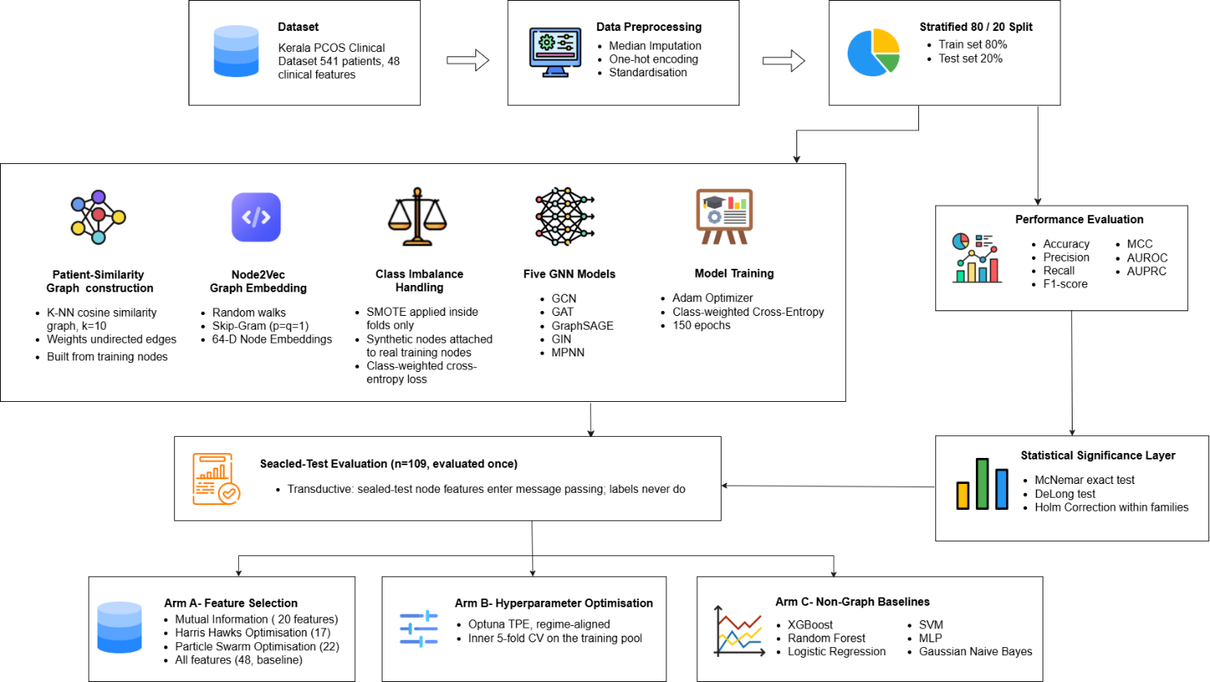

3.4.4 Patient-Similarity Graph Construction
Let $x_{i}∈R^{d}$ represent the standardized clinical feature vector for patient $i$. Pairwise similarity is defined as the cosine of the angle between two feature vectors:
$$s\left(i,j\right)=\frac{x_{i}⋅x_{j}}{∥x_{i}∥∥x_{j}∥} \left(3.1\right)$$
Cosine similarity is selected in preference to Euclidean distance. The reason behind is, after standardization, it captures patterns across clinical markers rather than the overall magnitude of their values. Patients with comparable clinical profiles are considered similar even when the absolute values of individual markers differ. This interpretation is more consistent with the clinical objective of identifying patients who exhibit similar characteristics.
Each patient is connected to the $k$ patients with the highest similarity ($k=10$), and the resulting directed edges are symmetrised to produce an undirected graph $G=\left(V,E\right)$. Edge weights are defined as $w_{ij}=max\left(0,s\left(i,j\right)\right)$. Negative similarities are clipped to zero because negatively correlated patients are not considered to provide evidence of a shared diagnosis under the adopted similarity model. Duplicate edges introduced during graph symmetrization are merged by retaining the maximum edge weight. The $k$-nearest-neighbour construction ensures that every node has a minimum degree of $k$. Nodes with substantially higher degrees represent hub patients that have been selected as neighbours by many others.

3.4.5 Structural Embedding
Graph topology provides information that clinical features alone cannot. A patient's position within the similarity graph, such as the density of its local neighborhood or its proximity to highly connected nodes, may itself carry predictive value. To make this structural information available to the classifier, a structural low-dimensional embedding is generated for each node.
Truncated random walks of length 20 are generated from each node (ten walks per node). The resulting node sequences are then treated as sentences used to train a skip-gram Word2Vec model [46], producing a 64-dimensional embedding for each patient. This corresponds to the Node2Vec algorithm [47] with both the return parameter and the in-out parameter set to unity ($p=q=1$). Under this configuration, the biased second-order random walk reduces to an unbiased first-order walk, making the procedure mathematically equivalent to DeepWalk [48].
The final representation of each node is obtained by concatenating the standardized clinical feature vector with the structural embedding, resulting in a 112-dimensional feature vector (48 clinical features and 64 embedding features) in the all-feature condition.
Structural embeddings are learned only from the training graph. Validation and test patients do not participate in the embedding process to prevent information leakage. Instead, the embedding for a validation or test patient $u$ is estimated inductively as the similarity-weighted mean of the embeddings of its $k$ nearest neighbors in the training graph:

zu=j∈Nku​max0,su,jzjj∈Nku​max0,su,j 3.2

3.4.6 Class-Imbalance Handling
Approximately one third of the patients belong to the positive class, producing a moderate level of class imbalance This issue is addressed using two complementary techniques, both applied only to the training partition. One of these is the Synthetic Minority Over-sampling Technique (SMOTE) [49], which generates additional positive instances by interpolating existing minority samples in the 112-dimensional feature space. After generation, each synthetic sample is then attached to the graph using the same $k$-nearest-neighbor construction adopted for the original data. However, the newly created nodes are connected only to genuine training samples. This prevents synthetic information from propagating to the validation or test sets during message passing. Second, the cross-entropy loss function is weighted inversely to the class frequencies, increasing the contribution of the minority class during optimization. SMOTE is fitted independently within each cross-validation fold and is never applied to the complete training set before partitioning or to the sealed test set, to prevent data leakage.

3.4.7 Evaluation Protocol and Metrics
Model selection was performed by ten-fold stratified cross-validation on the 432-patient training cohort, and final performance was evaluated once on the sealed 109 patient test set. The primary evaluation metric is the Matthews correlation coefficient (MCC):
$$MCC=\frac{TP⋅TN-FP⋅FN}{\sqrt{\left(TP+FP\right)\left(TP+FN\right)\left(TN+FP\right)\left(TN+FN\right)}} \left(3.3\right)$$
MCC is adopted as the main performance metric because it incorporates all four elements of the confusion matrix into a single measure and remains informative under class imbalance. On the other hand, accuracy can present an overly optimistic assessment by favoring the majority class. To provide a comprehensive evaluation, additional performance measures are reported, including the area under the receiver operating characteristic curve (AUROC), the area under the precision–recall curve (AUPRC), F1-score, accuracy, sensitivity, specificity, Cohen's $κ$, and the complete confusion matrix.

3.4.8 Statistical Significance Layer
Performance estimates computed from a test set of 109 patients should be interpreted carefully, as differences of only a few percentage points may correspond to the classification of just two or three additional patients. For this reason, comparative claims are supported by formal statistical inference instead of relying solely on point estimates. McNemar's exact test is used to compare paired hard-label predictions and determine whether two models differ significantly in their classification errors. DeLong's test is applied to compare paired AUROC values, while a paired bootstrap with 10,000 resamples is used to estimate a 95% confidence interval for the difference in MCC. Since multiple comparisons are performed against a common reference model, p-values are adjusted within each comparison family using the Holm–Bonferroni procedure. Fisher's exact test is conducted separately to confirm that the predictive performance of each model is significantly better than chance.
Table 3.4 Pipeline Configuration
Component | Parameter | Value
Graph construction | Similarity metric | Cosine similarity on standardized features
 | Neighbors k | 10
 | Edge weights | max(0, cosine); undirected; coalesced by maximum
 | Construction scope | Fold-local: built from training nodes only
Structural embedding | Method | Random walks + skip-gram Word2Vec (p = q = 1)
 | Dimension | 64
 | Walk length / walks per node | 20 / 10
 | Context window / epochs | 10 / 50
 | Unseen nodes | Inductive: similarity-weighted mean of k neighbors
Node features | Composition | Clinical features concatenated with structural embedding
 | Input dimension (all-feature) | 112 (48 + 64)
Class imbalance | Method | SMOTE (k = 5), applied inside folds only
 | Synthetic nodes | Connected to real training nodes only
 | Loss weighting | Class-weighted cross-entropy
Training (defaults) | Hidden dimension / dropout | 64 / 0.3
 | Optimizer / learning rate / weight decay | Adam / 1e-3 / 1e-4
 | Scheduler | ReduceLROnPlateau
 | Epochs (sealed test) | 150, fixed — no early stopping
 | Epochs (cross-validation) | 200 max, early stopping patience 30
Evaluation | Cross-validation | 10-fold stratified, on the training pool
 | Sealed test | Evaluated once; transductive
 | Seed | 42

System Design and Architecture
The complete pipeline is shown in Figure 3.1. Table 3.4 records the configuration of every stage in a single place.

3.5.1 Message-Passing Architectures
In this study, five graph neural network architectures were evaluated. All models used the same input representation, patient-similarity graph, class-imbalance strategy, loss function, optimizer and evaluation metrics. This ensured that any differences in performance could be attributed to the message-passing mechanism rather than to other components of the pipeline. Each model consisted two graph-convolutional layers followed by a linear classification head, with dropout between layers. The specifications of the evaluated models are summarized in Table 3.5.
Table 3.5 Architecture Specifications
Model | Convolution | Layers | Aggregation | Uses edge weights?
GCN | GCNConv | 2 conv + linear | Normalized mean (spectral) | Yes
GAT | GATConv | 2 conv + linear | Attention-weighted | No
GraphSAGE | SAGEConv | 2 conv + linear | Mean of neighbors, self-preserved | No
MPNN | NNConv | 2 conv + linear | Edge-conditioned mean | Yes
GIN | GINConv | 2 conv + linear | Sum, followed by MLP | No

The Graph Convolutional Network (GCN) [28] updates node representations by collecting information from neighboring nodes using a symmetrically normalized adjacency matrix:

hil+1=σj∈Ni∪{i}​1didjWlhjl 3.4

The Graph Attention Network (GAT) [29] extends the GCN framework by replacing fixed neighborhood normalization with learnable attention coefficients. This enables the model to assign greater importance to clinically informative neighbors while reducing the influence of less informative ones during message passing:

hil+1=σj∈Ni​αijWlhjl, αij=softmaxjLeakyReLUa⊤Whi‖Whj 3.5

GraphSAGE [30] adopts a different collection strategy by learning separate transformations for a node's own features and for the collected representation of its neighborhood before concatenating the two representations:

$$h_{i}^{\left(l+1\right)}=σ\left(W^{\left(l\right)}⋅\left[h_{i}^{\left(l\right)}‖{mean}_{j∈N\left(i\right)}h_{j}^{\left(l\right)}\right]\right) \left(3.6\right)$$

This architectural separation makes GraphSAGE particularly well suited to the present study. A patient's own clinical measurements are processed through a dedicated pathway rather than being averaged directly with those of neighboring patients. This allows the model to incorporate neighborhood information without overwhelming the individual's clinical profile. The Message-Passing Neural Network (MPNN) [27] extends this approach by conditioning the message transformation on the connecting edge. It learns a function that maps each edge weight to a corresponding transformation matrix and is therefore the only architecture, apart from GCN, that directly incorporates the cosine similarity edge weights during message passing.
The Graph Isomorphism Network (GIN) [31] uses sum aggregation followed by a multilayer perceptron, providing the greatest theoretical discriminative power among the evaluated architectures:
hil+1=MLPl1+ϵ⋅hil+j∈Ni​hjl 3.7

Because sum aggregation is unnormalized by design, GIN is inherently sensitive to variation in node degree. This characteristic has important implications for its performance on the patient-similarity graph.

3.5.2 Design Disclosure
Among the five architectures, only GCN and MPNN make direct use of the cosine similarity edge weights. GraphSAGE, GAT and GIN operate solely on the graph topology. GAT learns attention coefficients that replace the predefined edge weights during message passing.

Implementation and Simulation

3.6.1 The Fold-Local Training Loop
Within each of the ten cross-validation folds, the entire training pipeline is reconstructed from first principles. The feature scaler is fitted using only the training partition before being applied to the corresponding validation partition. A patient-similarity graph is then constructed from the training nodes, followed by the generation of structural embeddings on that graph. SMOTE is applied to the training data, and the resulting synthetic nodes are added into the graph using the $k$-nearest-neighbour procedure. Inductive embeddings are then estimated for the validation nodes, which are connected only to genuine training nodes before being inserted into the graph. Finally, a new model is initialized and trained using class-weighted cross-entropy loss. This complete regeneration of everything within each fold defines the fold-local protocol. This is the mechanism by which information leakage is prevented. During cross-validation, each model is trained for a maximum of 200 epochs with early stopping based on the validation AUROC. Selecting the model checkpoint based on performance on the validation fold introduces a well-recognized source of optimistic bias. The same data is used for both model selection and performance assessment. For this reason, the cross-validation results are used only to identify the final model. They are not interpreted as unbiased estimates of generalization performance and are not compared directly with the results obtained from the sealed test set.

3.6.2 The Sealed-Test Protocol
The sealed-test evaluation follows a training protocol that is different from the cross-validation procedure. Each model is trained on the complete 432-patient training cohort for a fixed budget of 150 epochs without early stopping. This avoids the need for an additional validation set, as the only remaining held-out data comprise the sealed test set, which must remain untouched until final evaluation. During training, node features from the sealed-test patients are included in the graph, making the evaluation transductive. However, their class labels are masked and excluded from the loss function. This ensures that they do not contribute to parameter updates. This transductive evaluation protocol is an intentional methodological choice rather than an implementation artefact and is explicitly disclosed whenever the results are compared with inductive tabular models.

3.6.3 The Determinism Check
The experimental pipeline incorporates an internal consistency check. The all-feature configuration under the default hyperparameter settings is evaluated twice, once as ALL_DEFAULT and once as the reference configuration BASELINE. By design, these represent the same experiment, and any discrepancy between their results would indicate the presence of hidden non-determinism, such as an unseeded random state, a device-dependent kernel, or an unintended dependency within the data-processing pipeline. The two configurations produced identical results across all twelve evaluation metrics and every element of the confusion matrix. The successful replication of these results provides evidence that the experimental pipeline is deterministic.

3.6.4 The Three Experimental Arms
Three independent questions are answered against the same sealed test set.
Arm A — Feature Selection. Four feature subsets were evaluated: the top 20 features ranked by mutual information, a 17-feature subset identified using Harris Hawks Optimization, a 22-feature subset obtained through Particle Swarm Optimization, and the complete set of 48 clinical features. The metaheuristic methods employed a wrapper-based fitness function that combined cross-validated MCC with a penalty for larger feature subsets under a reduced-cost search strategy. This fitness function was used to identify candidate feature subsets and not interpreted as an estimate of predictive performance. The performance of every selected subset was evaluated independently on the sealed test set.
Arm B — Hyperparameter Optimization. Hyperparameters were optimized using Optuna's Tree-structured Parzen Estimator (TPE) [50]. For each feature subset, an independent search was performed over the hidden dimension, dropout rate, learning rate, weight decay, neighborhood size ($k$), embedding dimension, optimizer and learning-rate scheduler using an inner five-fold cross-validation procedure on the training cohort. The optimization strategy was aligned with the final evaluation protocol, with every trial trained for a fixed 150 epochs and assessed using the terminal epoch without early stopping. Consequently, the optimization objective matched the deployment setting, ensuring that the search and evaluation procedures remained consistent. Each feature subset was subsequently evaluated on the sealed test set using both the default and the optimized hyperparameter configurations, combining a total of nine experimental configurations.
Arm C — Non-Graph Baselines. Six widely used tabular classifiers were included as baseline models. Those are XGBoost, Random Forest, a multilayer perceptron, regularized logistic regression, a support vector machine with a radial basis function (RBF) kernel, and Gaussian naïve Bayes. All models were trained using the same data partition as the graph neural networks. Feature scaling and SMOTE were also applied independently within each cross-validation fold to prevent information leakage. Hyperparameters were tuned using an inner five-fold grid search before the selected models were refitted on the complete training cohort and evaluated once on the sealed test set. Unlike the proposed graph-based models, these classifiers are inductive and operate directly on the clinical features without structural graph embeddings. Consequently, this comparison evaluates the proposed graph-learning framework against conventional tabular machine learning methods on the same dataset rather than serving as a controlled graph-versus-no-graph ablation study.

Tools and Technologies Used
All experiments were conducted in Kaggle Notebooks using an NVIDIA T4 GPU. Graph neural network models were implemented in PyTorch with the PyTorch Geometric library [51]. Structural embeddings were generated using the gensim implementation of Word2Vec, executed in single-threaded mode to ensure deterministic behavior. SMOTE was implemented through imbalanced-learn, metaheuristic optimization was performed using Mealpy, and hyperparameter optimization was carried out with Optuna. Classical machine learning models, evaluation metrics and cross-validation utilities were provided by scikit-learn, while statistical analyses were performed using SciPy and statsmodels. The exact software versions are listed in Table 3.6. To ensure reproducibility, all experiments were executed with a single global random seed of 42, and cuDNN was configured in deterministic mode.

Table 3.6 Computational Environment
Component | Version / setting
Platform | Kaggle Notebooks, NVIDIA T4 GPU (CUDA)
PyTorch | 2.10.0+cu128
PyTorch Geometric | 2.7.0 (architecture benchmark) / 2.8.0 (feature-selection and tuning phases)
Optuna | 4.9.0
Mealpy | 3.0.3
Structural embeddings | gensim Word2Vec (single-threaded, for determinism)
Class imbalance | imbalanced-learn (SMOTE)
Global seed | 42 (Python, NumPy, PyTorch, CUDA; cuDNN deterministic)

Summary
This chapter has presented a graph-based framework for detecting PCOS from routine clinical data. Firstly, patients are represented as nodes in a $k$-nearest-neighbour graph constructed using cosine similarity Each node is described by the concatenation of a standardized clinical feature vector and a structural embedding learned from random walks. Five message-passing architectures are evaluated using this shared representation under a common experimental protocol. The principal contribution of the methodology is not the selection of a particular graph neural network architecture but the design of the experimental protocol. This includes a sealed test set reserved for final evaluation, fold-local reconstruction of every data-dependent component, an internal consistency check for determinism, alignment between the hyperparameter optimization and deployment regimes, and a statistical inference framework for determining whether observed performance differences are meaningful. Chapter 4 presents the experimental results obtained using this framework.

Chapter 4

Implementation and Testing

Introduction
This chapter presents the results obtained using the proposed framework. It first describes the environment in which the system was implementation and the practical realization of the methodology outlined in Chapter 3. The evaluation protocol is presented next, together with the statistical procedures used to assess whether observed performance differences are statistically significant. The remainder of the chapter discusses the experimental findings in relation to the five research questions addressed by this study.
The findings are presented without preferential emphasis on positive outcomes. Instead, all results are reported as observed, including the negative or neutral outcomes returned by three of the five research questions. Firstly, hyperparameter optimization offering no measurable improvement over well-chosen default settings. Secondly, feature selection achieves greater parsimony without improving predictive performance. Lastly, the proposed graph-based framework performs competitively with conventional tabular machine learning models, rather than outperforming them. These outcomes are reported without qualification because the strength of the study lies in the rigor of its evaluation protocol, which must be applied consistently regardless of whether the results support or challenge the proposed approach.

System Setup and Environment
All experiments were conducted in Kaggle Notebooks using an NVIDIA T4 GPU, subject to a maximum session duration of twelve hours. The graph neural network models were implemented in PyTorch (2.10.0+cu128) with PyTorch Geometric. Structural embeddings were generated using the gensim implementation of Word2Vec, configured to use a single worker thread to ensure deterministic embedding generation. Class imbalance was addressed using imbalanced-learn and metaheuristic feature selection was performed with Mealpy (3.0.3), Hyperparameter optimization was employed by Optuna (4.9.0). Classical machine learning models, evaluation metrics and cross-validation utilities were provided by scikit-learn, with statistical analyses conducted using SciPy and statsmodels. The complete software versions are listed in Table 3.6. A single global seed of 42 was used to initialize the random states of Python, NumPy, PyTorch and CUDA. In addition, cuDNN was configured in deterministic mode with benchmarking disabled. The effectiveness of these measures was verified empirically rather than assumed. The headline configuration was executed independently in two notebooks developed at different times, producing per-patient predicted probabilities that differed by no more than 5.4 × 10⁻⁷. Both executions also achieved an identical Matthews correlation coefficient (MCC) of 0.8110 on the sealed test set.

Implementation of the System
The implementation was organized as a series of independent notebooks, with each stage taking the outputs of its predecessor through versioned files rather than shared memory. This design was motivated primarily by the twelve-hour execution limit imposed by Kaggle sessions. It also provides an important methodological advantage, which is every intermediate result is written to disk before being consumed by the next stage. This ensures that each reported result is traceable to a stored artefact rather than a temporary value retained in notebook memory.
The implementation pipeline consists of a data-cleaning notebook that produces the final 48 predictor dataset; five architecture specific notebooks that perform ten-fold cross-validation for GCN, GAT, GraphSAGE, MPNN and GIN on the training cohort; a sealed-test notebook that trains each architecture on the complete training cohort and evaluates it once on the sealed test set; a feature-selection notebook that performs the mutual information and metaheuristic searches; a hyperparameter optimization notebook that conducts the Optuna search for each feature subset; a combined evaluation notebook that assesses the nine feature-selection and hyperparameter configurations on the sealed test set; a baseline notebook that trains the six conventional tabular classifiers using the identical data partition; and a statistical analysis notebook that consumes the per-patient prediction vectors produced by the preceding stages to perform the paired statistical tests. The per-patient prediction vectors build the foundation of the evaluation framework. Because every evaluation stage exports the true class label, the predicted probability and the predicted class for each of the 109 patients in the sealed test set. As a result, any pair of models can be compared directly using paired statistical tests without requiring retraining. As an additional consistency check, the baseline notebook verifies before model training begins that the reconstructed sealed-test labels are identical to those generated by the graph-based pipeline. Execution is terminated automatically if any discrepancy is detected.

Evaluation and Testing
Model selection was performed by using ten-fold stratified cross-validation on the 432-patient training cohort. Final performance was evaluated once on the sealed test set comprising 109 patients (73 negative and 36 positive). The primary evaluation metric is the Matthews correlation coefficient (MCC), defined in Equation 3.3. To provide a comprehensive assessment of model performance, AUROC, AUPRC, F1-score, accuracy, sensitivity, specificity, Cohen's kappa and the confusion matrix are also evaluated. Because the sealed test has 109 patients, of whom 36 are positive, a difference of one percentage point in accuracy corresponds to the reassignment of a single patient. Point estimates should therefore not be interpreted in isolation. Instead, every comparative claim is supported by formal statistical inference. Each comparison is evaluated using three paired statistical procedures: McNemar's exact test for paired hard-label predictions, DeLong's test for paired AUROC values, and a paired bootstrap with 10,000 resamples to estimate a 95% confidence interval for the difference in MCC. Because several models are compared against a single reference, the p-values within each family of comparisons are adjusted by the Holm-Bonferroni procedure. Fisher’s exact test is applied separately to establish that each model discriminates above chance. Two families of comparison are defined. Family 1 compares the selected GraphSAGE architecture with the remaining four gnn architectures. Family 2 compares the all-feature baseline with the feature-selected configurations. The ALL_DEFAULT configuration is excluded from this family because it is the identity twin of BASELINE and its inclusion would test a model against itself.

Results and Discussion

4.5.1 RQ1: Can a Patient-Similarity GNN Detect PCOS From Routine Clinical Data?
The proposed framework demonstrates clinically meaningful predictive performance. On the sealed test set, GraphSAGE achieves an MCC of 0.8110, an AUROC of 0.9486 and an accuracy of 0.9174. The model correctly identifies 30 of the 36 patients with PCOS while producing only three false-positive predictions among the 73 patients without the condition (Table 4.1 and Table 4.2). This corresponds to a sensitivity of 0.8333 and a specificity of 0.9589. Table 4.1 summarizes the complete set of evaluation metrics for all five graph neural network architectures, ranked according to their MCC values.

Table 4.1 Sealed-Test Metrics For the Five Architectures, Ranked by MCC
# | Model | Acc | Prec | Rec | F1 | MCC | AUROC | AUPRC | Sens | Spec
1 | GRAPHSAGE | 0.9174 | 0.9091 | 0.8333 | 0.8696 | 0.8110 | 0.9486 | 0.9309 | 0.8333 | 0.9589
2 | GAT | 0.8624 | 0.7838 | 0.8056 | 0.7945 | 0.6912 | 0.9239 | 0.8873 | 0.8056 | 0.8904
3 | GCN | 0.8532 | 0.7941 | 0.7500 | 0.7714 | 0.6640 | 0.9091 | 0.8716 | 0.7500 | 0.9041
4 | MPNN | 0.8349 | 0.7812 | 0.6944 | 0.7353 | 0.6182 | 0.9277 | 0.8904 | 0.6944 | 0.9041
5 | GIN | 0.7798 | 0.6200 | 0.8611 | 0.7209 | 0.5671 | 0.8946 | 0.8618 | 0.8611 | 0.7397

Model | TP | FP | TN | FN
GRAPHSAGE | 30 | 3 | 70 | 6
GAT | 29 | 8 | 65 | 7
GCN | 27 | 7 | 66 | 9
MPNN | 25 | 7 | 66 | 11
GIN | 31 | 19 | 54 | 5
Table 4.2 Confusion-Matrix Components On the Sealed Test

Fisher's exact test confirms that all five architectures discriminate significantly better than chance (Table 4.12). The central question is therefore not whether the proposed framework is capable of distinguishing between PCOS-positive and PCOS-negative patients, but how effectively it performs relative to alternative approaches. Two observations provide important context for interpreting the headline performance. The first concerns the balance between false negatives and overall accuracy. GraphSAGE fails to identify six of the thirty-six patients with PCOS. In the context of clinical screening, the consequences of a missed diagnosis are generally more serious than those of a false positive result. For this reason, a clinician is likely to place greater emphasis on the sensitivity of 0.8333 than on the overall accuracy of 0.9174. Figure 4.6 shows how precision, recall and F1 vary with the decision threshold, and establishes that sensitivity can be increased by selecting a different operating point at the expense of reduced specificity. The decision threshold of 0.5 adopted throughout this study represents the conventional default and was not optimized using the sealed test set. The second observation is that the graph structure contributes meaningful predictive information rather than serving only as a computational platform. The structural embeddings alone partially separate the classes before any clinical feature reaches the classifier. As shown in Figure 4.8, patients from the sealed test set are embedded within the same manifold as the training cohort rather than forming a disjoint region, supporting the validity of the inductive embedding procedure for previously unseen patients.
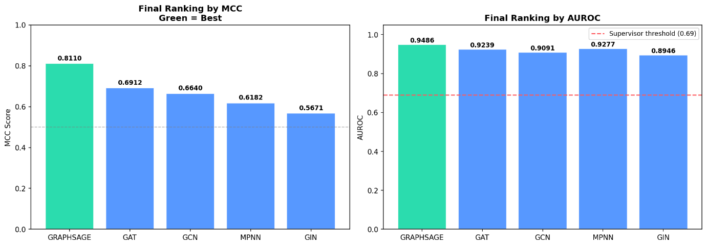
Figure 4.1 Final Architecture Ranking by MCC on the Sealed Test
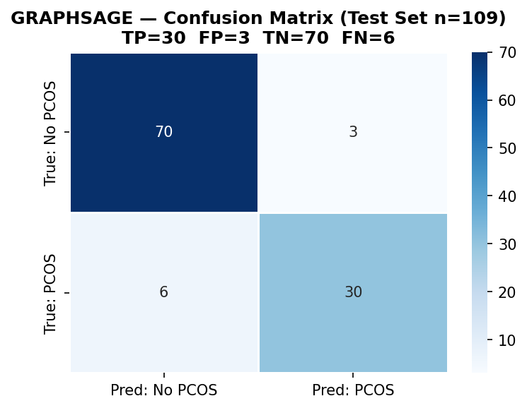

Figure 4.2 GraphSAGE Confusion Matrix (Sealed Test)
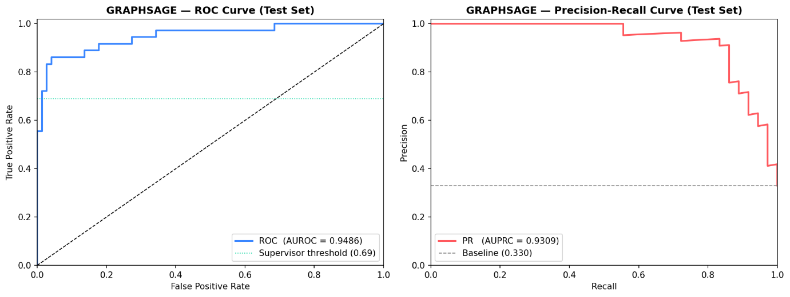

Figure 4.3 GraphSAGE ROC and Precision-Recall Curves (Sealed Test)

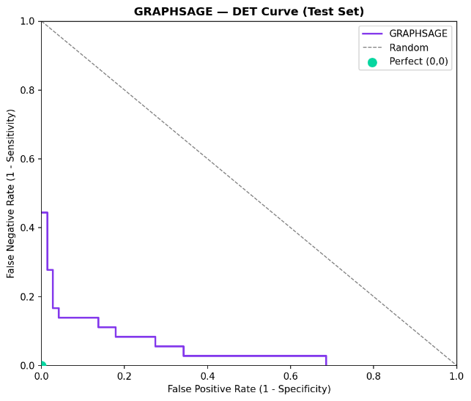

Figure 4.4 DET Curve for GraphSAGE

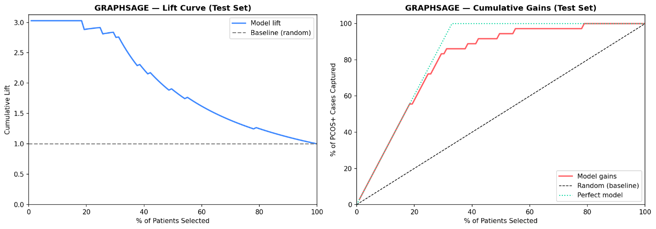
Figure 4.5 Lift and Cumulative-Gains Curves for GraphSAGE

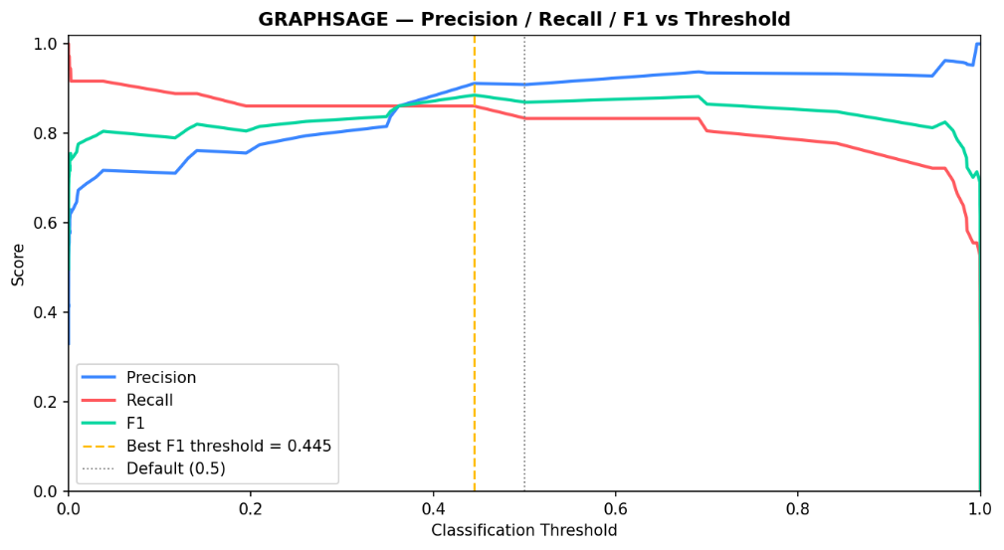

Figure 4.6 Precision, Recall and F1 as a Function of the Decision Threshold, GraphSAGE
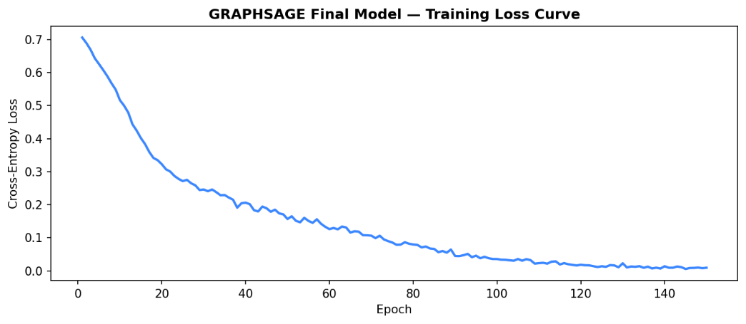

Figure 4.7 Training-Loss Curve for the Final GraphSAGE Model
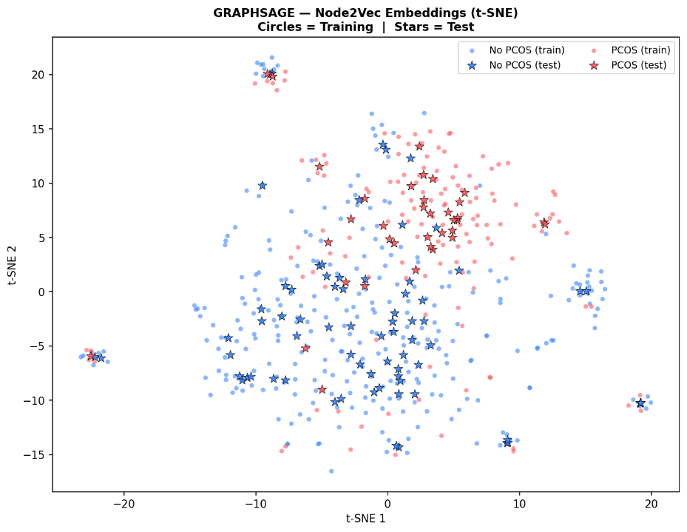

Figure 4.8 t-SNE projection of the structural embeddings of the full graph

4.5.2 RQ2: Which Architecture is Best Suited to a Patient-Similarity Graph, and are the Differences Real?
GraphSAGE achieves the highest performance in both the cross-validation and sealed-test evaluations, with the ranking of the best-performing architecture remaining consistent across the two stages. Table 4.3 presents the cross-validation results that informed the architecture selection process.

Table 4.3 Ten-fold cross-validation on the training pool (mean +/- standard deviation)
Metric | GCN | GAT | GraphSAGE | MPNN | GIN
accuracy | 0.8407 +/- 0.0866 | 0.8151 +/- 0.0774 | 0.8728 +/- 0.0608 | 0.8382 +/- 0.0745 | 0.7244 +/- 0.1695
precision | 0.7580 +/- 0.1361 | 0.7065 +/- 0.1290 | 0.7987 +/- 0.0889 | 0.7503 +/- 0.1186 | 0.5945 +/- 0.1453
recall | 0.7733 +/- 0.1833 | 0.7733 +/- 0.1243 | 0.8238 +/- 0.1366 | 0.7733 +/- 0.1373 | 0.8724 +/- 0.1204
f1 | 0.7558 +/- 0.1426 | 0.7331 +/- 0.1079 | 0.8064 +/- 0.0944 | 0.7561 +/- 0.1101 | 0.6917 +/- 0.1118
mcc | 0.6484 +/- 0.1949 | 0.5997 +/- 0.1655 | 0.7175 +/- 0.1390 | 0.6406 +/- 0.1650 | 0.5071 +/- 0.2255
auroc | 0.9136 +/- 0.0695 | 0.9144 +/- 0.0570 | 0.9313 +/- 0.0564 | 0.9097 +/- 0.0647 | 0.9265 +/- 0.0544
auprc | 0.8643 +/- 0.1011 | 0.8720 +/- 0.0898 | 0.8944 +/- 0.0820 | 0.8673 +/- 0.1032 | 0.8856 +/- 0.0939
sensitivity | 0.7733 +/- 0.1833 | 0.7733 +/- 0.1243 | 0.8238 +/- 0.1366 | 0.7733 +/- 0.1373 | 0.8724 +/- 0.1204
specificity | 0.8736 +/- 0.0934 | 0.8353 +/- 0.0865 | 0.8969 +/- 0.0563 | 0.8694 +/- 0.0704 | 0.6526 +/- 0.2749
kappa | 0.6396 +/- 0.1997 | 0.5931 +/- 0.1661 | 0.7123 +/- 0.1386 | 0.6357 +/- 0.1651 | 0.4810 +/- 0.2307
The cross-validation results should be read with an important methodological qualification. Within each fold, the reported model checkpoint is selected on the basis of the highest validation AUROC achieved on that same fold. So, the cross-validation metrics are subject to optimistic bias and are used only for model selection. They are never compared numerically against the sealed-test results of Table 4.1. The main finding for RQ2 comes from the inferential layer, rather than the point estimates alone. Table 4.10 summarizes the Family 1 comparisons between GraphSAGE and each of the four alternative graph neural network architectures. For each comparison, McNemar's exact test, DeLong's test, a bootstrap confidence interval for the difference in MCC, and Holm-adjusted p-values are reported.
Table 4.10 Family 1 - GraphSAGE Against the Alternative Architectures
Comparison | b/c | McNemar p | Holm | DeLong p | Holm | Delta-MCC | 95% CI on Delta-MCC
GraphSAGE vs GCN | 10/3 | 0.0923 | 0.1846 | 0.0243 | 0.0730 | +0.1469 | [+0.000, +0.300]
GraphSAGE vs GAT | 11/5 | 0.2101 | 0.2101 | 0.2831 | 0.5662 | +0.1197 | [-0.041, +0.286]
GraphSAGE vs MPNN | 11/2 | 0.0225 | 0.0674 | 0.3703 | 0.5662 | +0.1928 | [+0.050, +0.346]
GraphSAGE vs GIN | 19/4 | 0.0026 | 0.0104 | 0.0176 | 0.0705 | +0.2439 | [+0.083, +0.409]
After adjustment for multiple comparisons, only one difference remains statistically significant. GraphSAGE outperforms GIN, with a Holm-adjusted McNemar p-value of 0.0104 and an MCC improvement of +0.2439. The corresponding 95% confidence interval, [+0.083, +0.409], excludes zero, indicating a statistically reliable advantage. In contrast, the performance differences between GraphSAGE and GCN, GAT, or MPNN are not statistically significant. The Holm-adjusted p-values range from 0.0674 to 0.2101, and the confidence interval for the MCC difference between GraphSAGE and GAT (+0.1197) includes zero.
This finding reflects the statistical power of the study and merits explicit consideration, as it shapes the interpretation of all subsequent results. An MCC difference of +0.1197 is a margin that might be presented as a meaningful improvement in many applied studies, but it cannot be distinguished from sampling variability in a test set of 109 patients. The conclusion for RQ2 is therefore twofold. First, GraphSAGE shows the strongest overall performance and is the appropriate architecture to be carried forward in the remainder of the study. Second, the available evidence does not support that GraphSAGE is statistically superior to GCN, GAT or MPNN on this cohort.
The behavior of GIN is particularly informative rather than merely incidental. Because its aggregation function is based on an unnormalized sum, a node's representation increases with its degree. On the patient-similarity graph, where highly connected hub patients naturally acquire larger degrees, this property leads to unstable training dynamics. The effect can be seen in the confusion matrix. GIN achieves the highest sensitivity of all evaluated models (0.8611). But it does so by over-predicting the positive class. This results in 19 false-positive predictions and the lowest specificity observed in the study. The same pattern can be seen during cross-validation, where one fold collapsed to predicting every patient as positive. The evidence therefore suggests that GIN's behavior arises from its aggregation mechanism rather than from the implementation, consistent with the behavior expected from message passing on an unnormalized similarity graph.
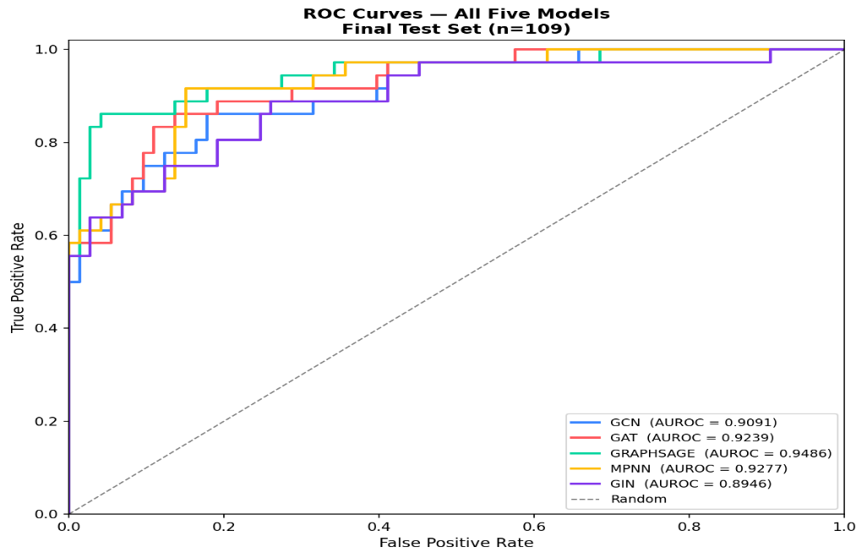

Figure 4.9 ROC Overlay for the Five Architectures
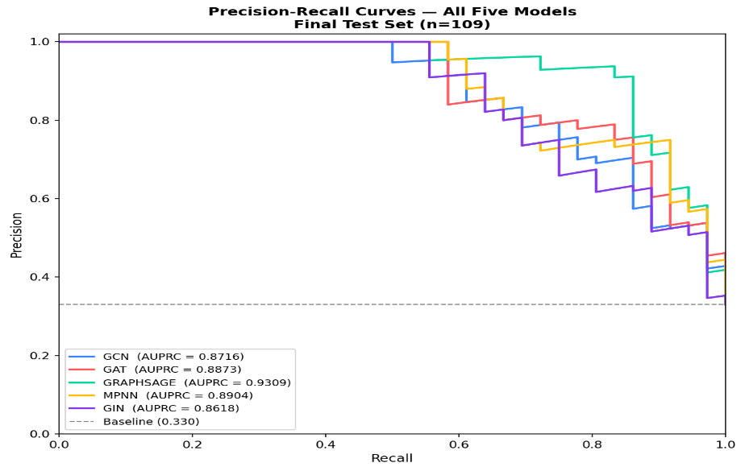

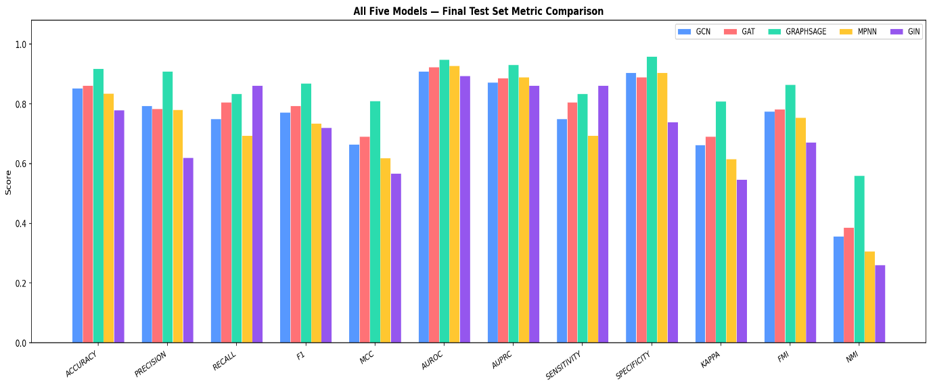
Figure 4.10 Precision-Recall Overlay for the Five Architectures
Figure 4.11 Metric Comparison Across the Five Architectures
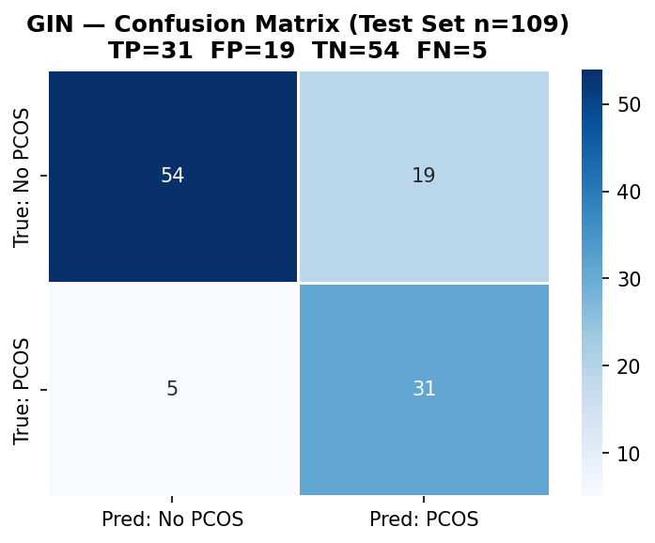

Figure 4.12 GIN Confusion Matrix
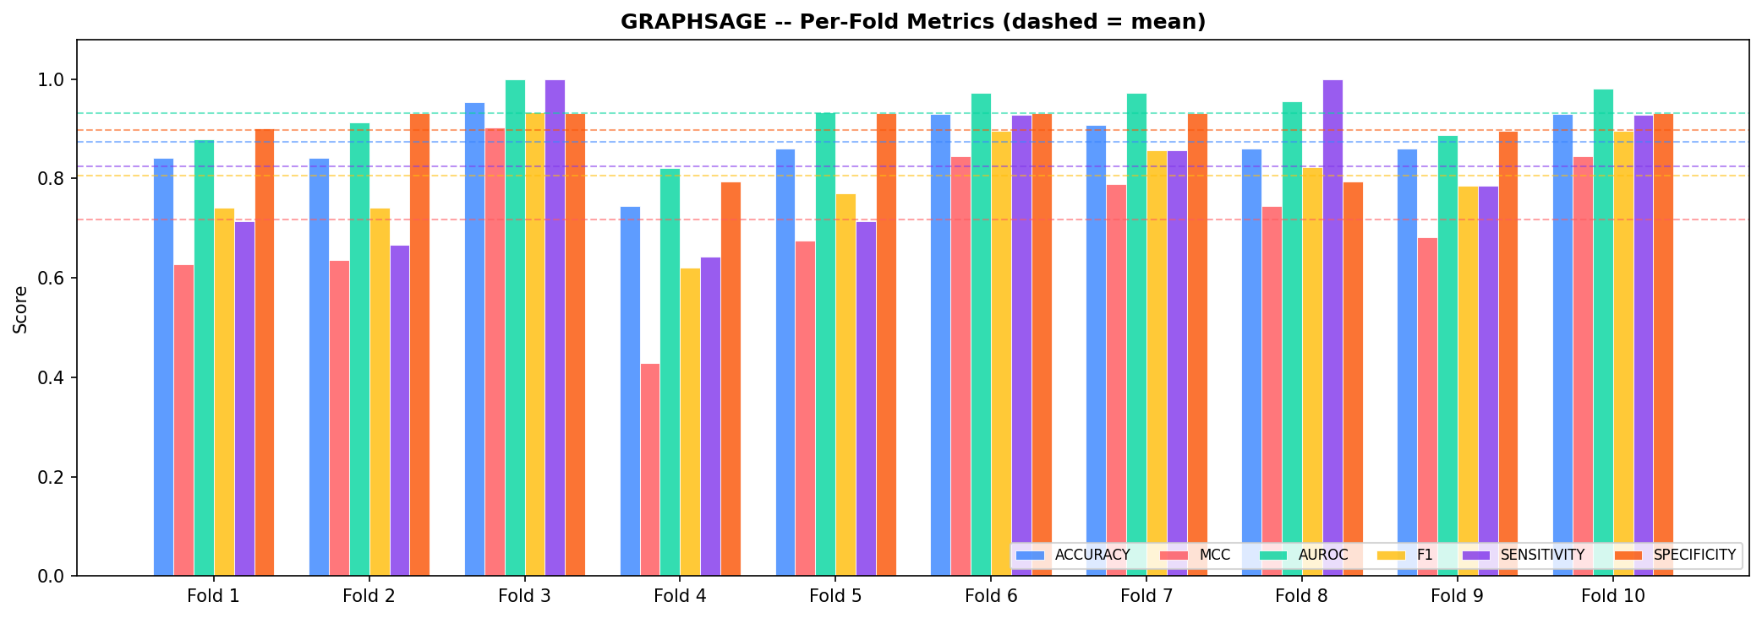
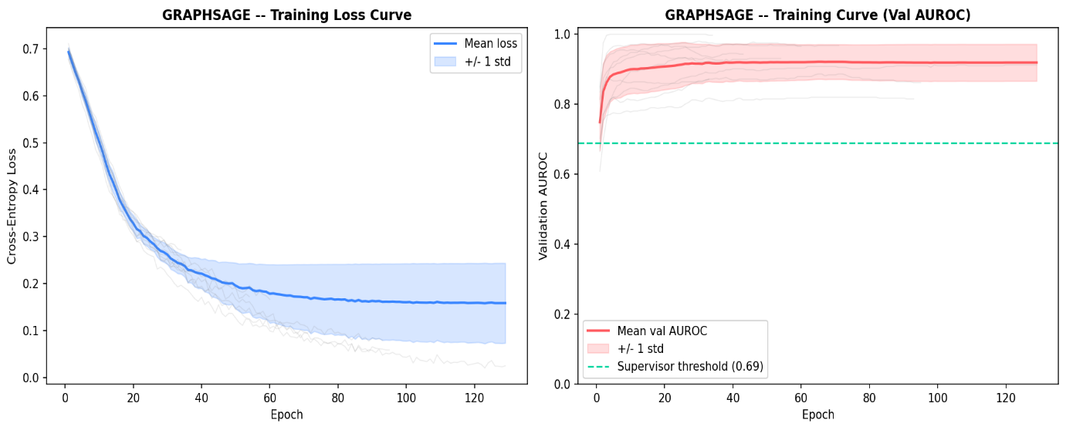
Figure 4.13 GraphSAGE training loss and validation AUROC across epochs

Figure 4.14 Per-fold metric variation for GraphSAGE.

4.5.2 RQ3: Does Feature Selection Improve Detection, or Only Parsimony?
Four feature subsets were evaluated on the sealed test set. They are as follows: the top 20 features ranked by mutual information, a 17-feature subset selected using Harris Hawks Optimization (HHO), a 22-feature subset obtained through Particle Swarm Optimization (PSO), and the complete set of 48 predictors. The composition of each subset is presented in Table 4.4.

Table 4.4 Feature Subsets Carried into Sealed-Test Evaluation
Subset | k | Features
MI | 20 | Weight_kg, Cycle_RI, Cycle_length_days, Marriage_yrs, FSH_LH_ratio, Hip_inch, WHR, AMH, PRL, PRG, WeightGain, HairGrowth, SkinDarkening, HairLoss, Pimples, FastFood, Follicle_L, Follicle_R, Endometrium, LH_FSH_ratio
HHO | 17 | Hb_gdl, Cycle_RI, Cycle_length_days, Marriage_yrs, Pregnant, Abortions, BetaHCG_I, FSH, TSH, HairGrowth, SkinDarkening, HairLoss, Pimples, RegExercise, Follicle_R, FSize_L, BG_16
PSO | 22 | Pulse_bpm, Hb_gdl, Cycle_length_days, Abortions, BetaHCG_I, FSH, Waist_inch, WHR, TSH, PRG, HairGrowth, SkinDarkening, HairLoss, Pimples, FastFood, RegExercise, Follicle_L, Follicle_R, BG_12, BG_15, BG_16, BG_17
ALL | 48 | All predictors (Table 3.2)

Table 4.5 Sealed-Test Results for the Nine Configurations
Configuration | k | Acc | F1 | MCC | AUROC | AUPRC | Sens | Spec
MI_DEFAULT | 20 | 0.9266 | 0.8889 | 0.8341 | 0.9456 | 0.9252 | 0.8889 | 0.9452
HHO_DEFAULT | 17 | 0.9174 | 0.8767 | 0.8148 | 0.9410 | 0.9325 | 0.8889 | 0.9315
ALL_DEFAULT | 48 | 0.9174 | 0.8696 | 0.8110 | 0.9486 | 0.9309 | 0.8333 | 0.9589
BASELINE | 48 | 0.9174 | 0.8696 | 0.8110 | 0.9486 | 0.9309 | 0.8333 | 0.9589
PSO_DEFAULT | 22 | 0.8440 | 0.7536 | 0.6411 | 0.8988 | 0.8700 | 0.7222 | 0.9041
MI_TUNED | 20 | 0.9083 | 0.8649 | 0.7962 | 0.9437 | 0.9286 | 0.8889 | 0.9178
HHO_TUNED | 17 | 0.8991 | 0.8493 | 0.7736 | 0.9368 | 0.9115 | 0.8611 | 0.9178
ALL_TUNED | 48 | 0.8807 | 0.8219 | 0.7324 | 0.9353 | 0.8936 | 0.8333 | 0.9041
PSO_TUNED | 22 | 0.8716 | 0.8108 | 0.7143 | 0.9197 | 0.9017 | 0.8333 | 0.8904

ALL_DEFAULT and BASELINE are, by design, identical experimental configurations. Their agreement across every evaluation metric and every element of the confusion matrix confirms the determinism check described in Section 3.6.3. This successful consistency check provides confidence that the remaining comparisons in the table are free from unintended implementation variability. Again, the highest MCC is achieved by the MI_DEFAULT configuration, which records a value of 0.8341 compared with 0.8110 for the baseline while using only 20 of the original 48 features. The descriptive differences between each configuration and the baseline are summarized in Table 4.6.
Table 4.6 Feature-selection effect relative to the 48-feature baseline (descriptive; see Table 4.11 for the inferential result).
Comparison | k | MCC | Delta-MCC | AUROC | Delta-AUROC
MI vs BASELINE | 20 | 0.8341 | +0.0231 | 0.9456 | -0.0030
HHO vs BASELINE | 17 | 0.8148 | +0.0039 | 0.9410 | -0.0076
PSO vs BASELINE | 22 | 0.6411 | -0.1698 | 0.8988 | -0.0498

Table 4.11 Family 2 - the all-feature baseline against the feature-selected configurations
Comparison | b/c | McNemar p | Holm | DeLong p | Holm | Delta-MCC | 95% CI on Delta-MCC
BASELINE vs MI_DEFAULT | 4/5 | 1.0000 | 1.0000 | 0.8113 | 1.0000 | -0.0231 | [-0.148, +0.095]
BASELINE vs HHO_DEFAULT | 5/5 | 1.0000 | 1.0000 | 0.5886 | 1.0000 | -0.0039 | [-0.133, +0.127]

The inferential analysis provides a clear answer to RQ3, one that differs from the impression conveyed by the descriptive results alone. Neither the MI nor the HHO feature subset performs significantly differently from the baseline. For the comparison between MI and the baseline, McNemar's exact test generates a p-value of 1.0000, with four and five discordant predictions, respectively. The corresponding 95% confidence interval for the difference in MCC, [-0.148, +0.095], includes zero by a substantial margin. Although MI achieves an improvement of +0.0231 MCC, this difference reflects the net reclassification of only a single patient and cannot be distinguished from sampling variability.
The appropriate interpretation is therefore a parsimony result, not a performance gain. Mutual information feature selection reduces the input panel by 58%, from 48 predictors to 20, while maintaining detection performance within the level of resolution afforded by this cohort. From a deployment perspective, this represents a meaningful practical advantage. Fewer input variables reduce the data collection burden, simplify the clinical assessment, and lessen the chances of missing values during inference. However, the results do not support the conclusion that feature selection improves the model's ability to detect PCOS. For this reason, the configuration is referred to throughout this thesis as MI-guided rather than MI-enhanced.
The composition of the retained features further supports the interpretation that the primary benefit is parsimony rather than improved predictive performance. The MI subset preserves clinically relevant variables, including ultrasound follicle counts, menstrual cycle regularity, AMH, the LH/FSH ratio, and the full symptom profile, all of which are recognized by the Rotterdam criteria and the wider clinical literature as important indicators of PCOS.
By contrast, the feature subsets selected by the metaheuristic methods are less clinically credible. The PSO subset retains four blood-group dummy variables while excluding AMH, whereas the HHO subset retains one blood-group dummy variable and likewise omits AMH. As blood group has no established association with PCOS, its selection is more plausibly explained by the optimizer exploiting incidental patterns within a relatively small training cohort than by the identification of a genuine clinical signal. This interpretation is supported by the sealed-test results, where PSO records the lowest performance of the four feature-selection strategies (MCC = 0.6411). Accordingly, although the metaheuristic subsets are reported for completeness, they are not recommended as the preferred feature-selection configuration.

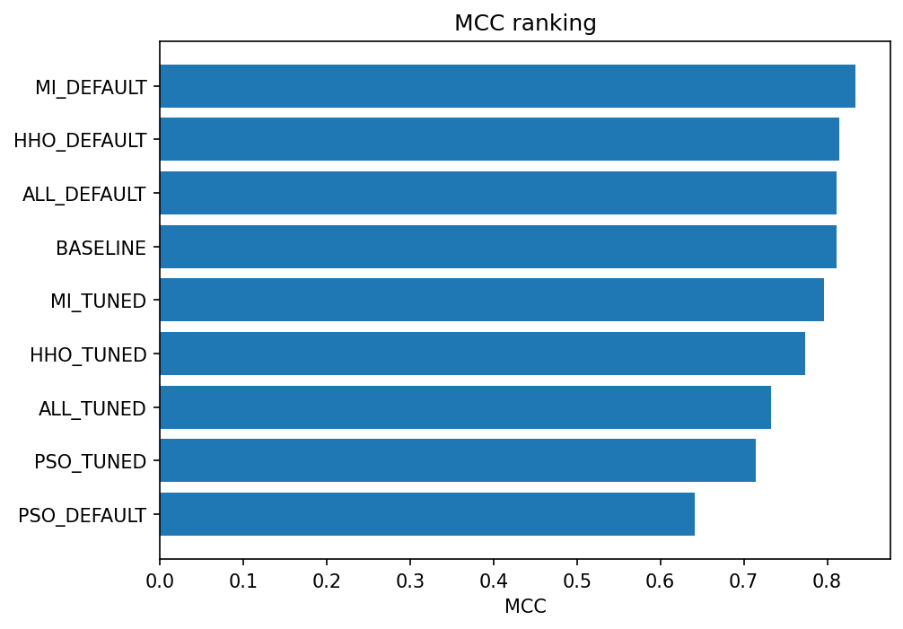

Figure 4.15 MCC Ranking of the Nine Sealed-Test Configurations

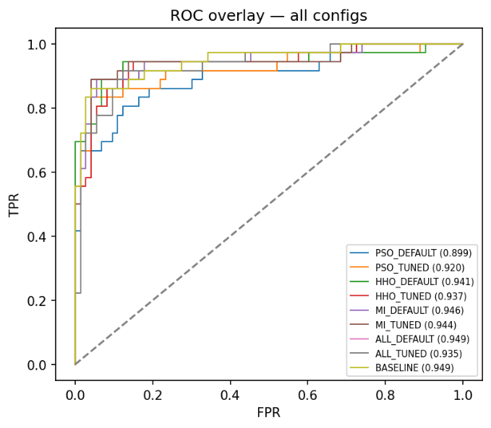
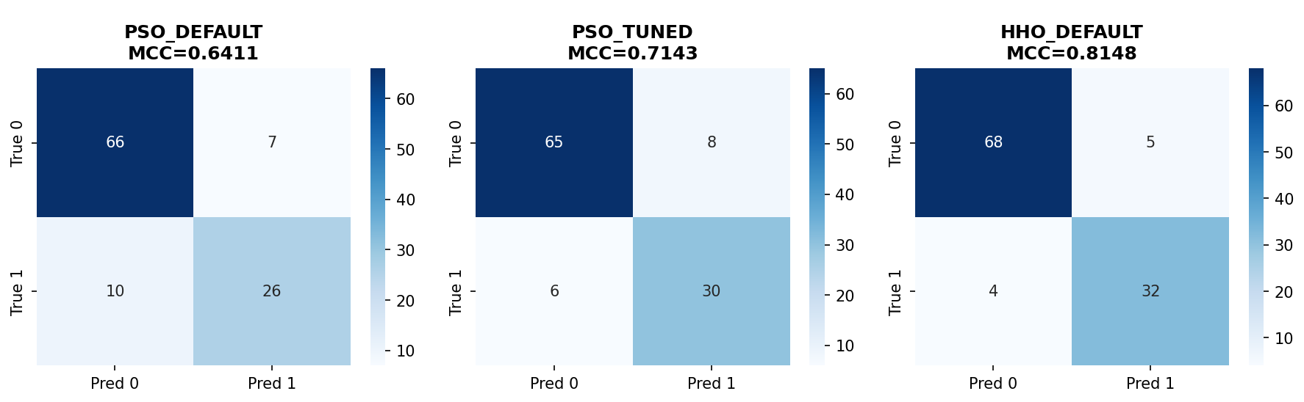
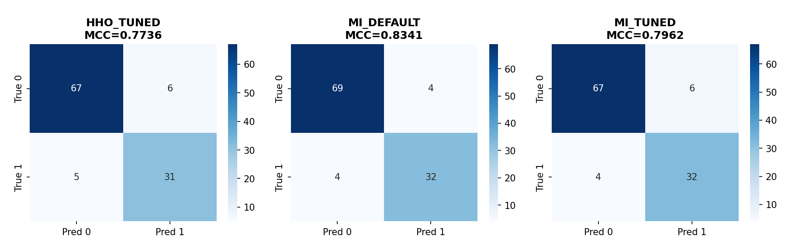
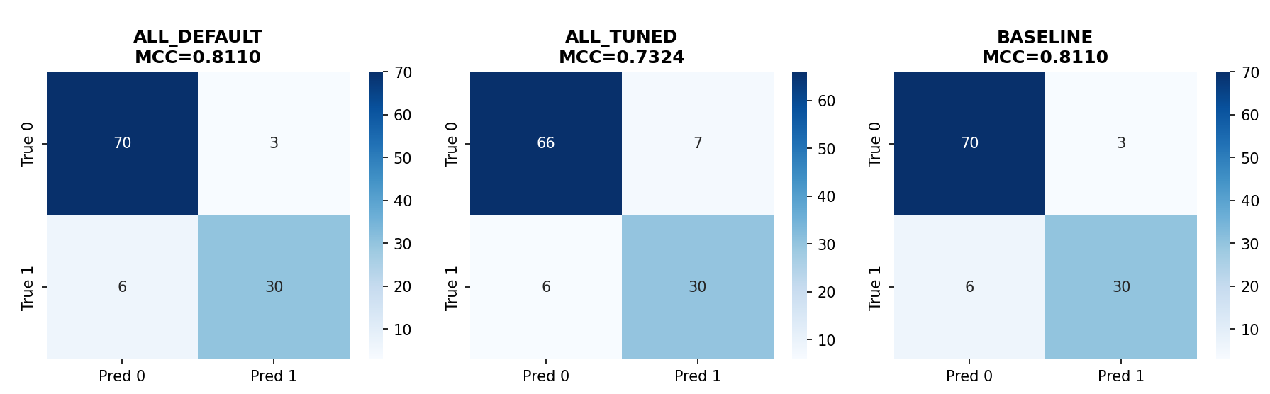
Figure 4.16 Confusion Matrices for All Nine Configurations (Sealed Test)

Figure 4.17 ROC Overlay Across the Nine Configurations

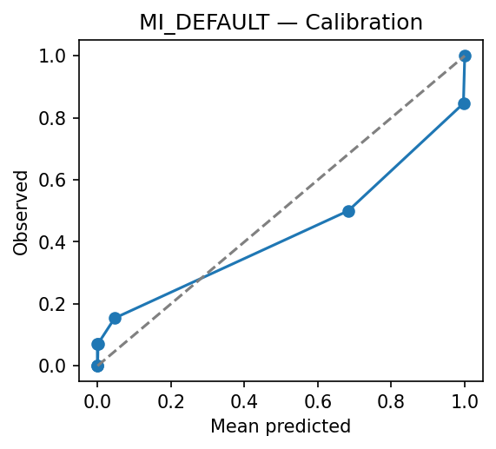
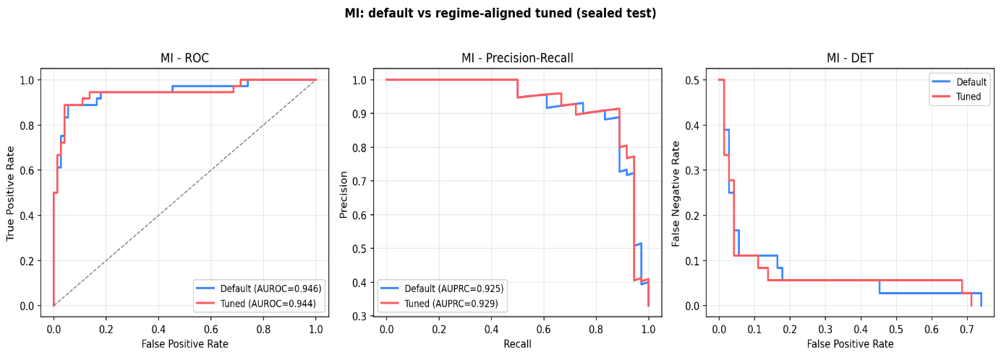
Figure 4.18 MI subset: ROC, precision-recall and DET curves

Figure 4.19 Calibration curve for MI_DEFAULT on the sealed test

4.5.4 RQ4: Does Hyperparameter Optimization Improve on Well-Chosen Defaults?
Hyperparameter Optimization does not improve on well-chosen defaults; this is a negative finding. The optimization procedure was intentionally designed to maximize the chances of identifying an improved configuration. Optuna's Tree-structured Parzen Estimator explored eight hyperparameters for each feature subset independently, using 50 trials for the metaheuristic subsets and 30 trials for the remaining configurations. The hyperparameters are hidden dimension, dropout rate, learning rate, weight decay, neighborhood size, embedding dimension, optimizer and learning-rate scheduler. Importantly, the search strategy was aligned with the final evaluation protocol. Every trial was trained and evaluated under exactly the same conditions used for deployment: a fixed budget of 150 epochs, evaluation at the terminal epoch, and no early stopping. Consequently, the optimization objective matched the final evaluation setting. In addition, the default hyperparameter configuration was enqueued as the first trial in every Optuna study, ensuring that the optimization process could not identify a configuration performing worse than the defaults under its own objective function. The optimal hyperparameter settings identified by the search are summarized in Table 4.8.

Table 4.7 Effect of regime-aligned hyperparameter optimization on the sealed test
(Positive delta favors tuning)
Feature set | MCC default | MCC tuned | Delta-MCC | AUROC default | AUROC tuned | Delta-AUROC
MI | 0.8341 | 0.7962 | -0.0379 | 0.9456 | 0.9437 | -0.0019
HHO | 0.8148 | 0.7736 | -0.0412 | 0.9410 | 0.9368 | -0.0042
ALL | 0.8110 | 0.7324 | -0.0785 | 0.9486 | 0.9353 | -0.0133
PSO | 0.6411 | 0.7143 | +0.0732 | 0.8988 | 0.9197 | +0.0209

Subset | k | Inner CV-MCC | hidden | dropout | lr | weight decay | k-NN | embed | optimiser | scheduler
PSO | 22 | 0.7829 | 32 | 0.404 | 1.48e-03 | 4.55e-04 | 12 | 64 | adamw | cosine
HHO | 17 | 0.7738 | 64 | 0.351 | 2.45e-04 | 7.64e-05 | 10 | 64 | adam | plateau
MI | 20 | 0.7712 | 32 | 0.498 | 2.47e-03 | 2.65e-04 | 20 | 64 | adam | cosine
ALL | 48 | 0.7296 | 128 | 0.374 | 7.81e-04 | 1.39e-05 | 8 | 64 | adamw | cosine
Table 4.8 Optuna optima per feature subset. The inner CV-MCC column is the search fitness surface, not a performance estimate.

Hyperparameter optimization does not translate into improved performance on the sealed test set. Of the four feature subsets, tuning reduces performance in three, including the all-feature configuration, where the MCC decreases from 0.8110 to 0.7324. The only improvement is observed for the PSO subset, whose MCC increases by 0.0732. Notably, PSO is also the weakest-performing feature subset before optimization and therefore has the greatest scope for improvement. The highest-performing configuration in the study, MI_DEFAULT, achieves its results using the default hyperparameter settings rather than the optimized ones.
The results do not suggest that the optimization procedure itself was unsuccessful. On the inner cross-validation surface the search succeeded: the tuned configuration for the all-feature set scores 0.7296 against 0.6696 for the defaults, a substantial improvement on the criterion being optimized. The limitation arises when this improvement is evaluated on previously unseen data. With 432 patients in the training cohort, each fold of the inner five-fold cross-validation contains approximately 345 training patients and 87 validation patients. Under these conditions, an optimization procedure that maximizes performance on the validation fold has considerable opportunity to adapt to characteristics specific to that sample rather than to the underlying data-generating process. The improvement is therefore genuine within the optimization framework but does not generalize to the independent sealed test set of 109 patients.
Two conclusions can be drawn from these findings. First, the default configuration which has hidden dimension of 64, dropout of 0.3, the Adam optimizer with a learning rate of 1e-3, and k = 10 is effectively near-optimal for the proposed pipeline. The observed performance appears to come primarily from the underlying representation and evaluation protocol rather than from favorable hyperparameter selection. Second, for a cohort of this size, hyperparameter optimization is more likely to introduce optimistic bias than to deliver reproducible performance gains. This is a cautionary finding for the wider literature, in which extensive metaheuristic tuning on small clinical cohorts is routinely reported as a performance gain without a sealed test to check whether the gain survives.
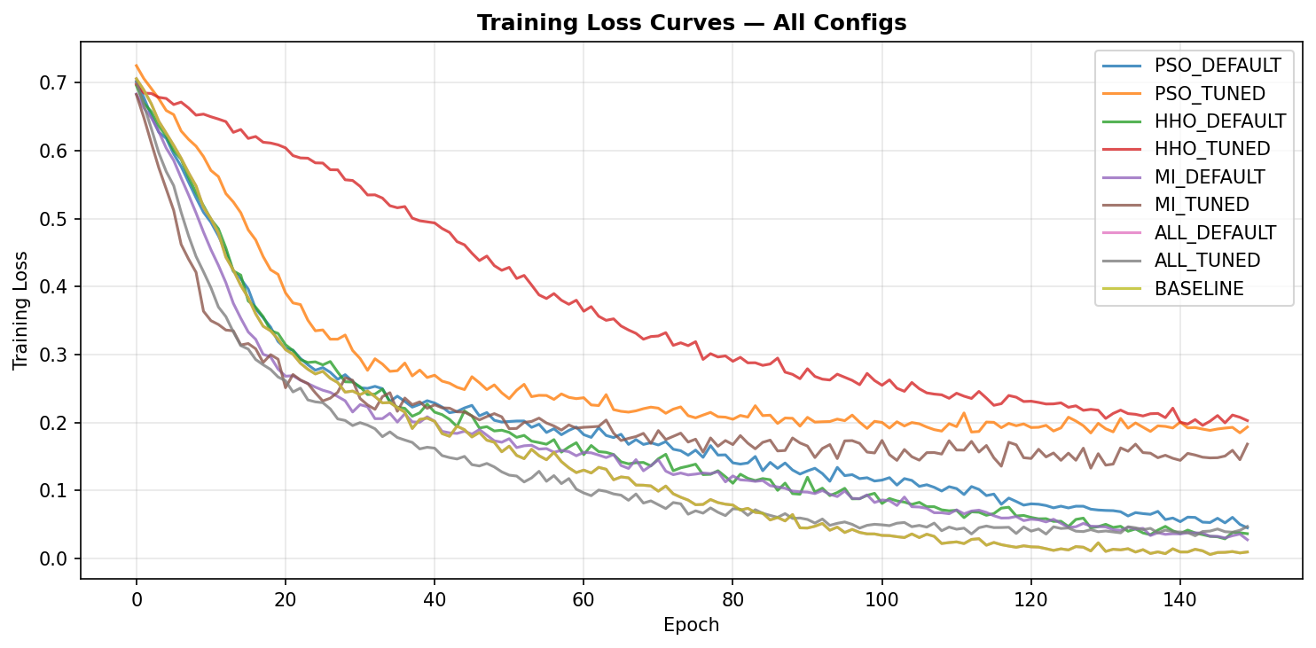
Figure 4.20 Training-Loss Curves for All Nine Configurations

4.5.5 RQ5: What Does the Graph Add Over Standard Tabular Classifiers?
The proposed graph-based framework performs competitively with strong tabular machine learning baselines but does not demonstrate statistically superior performance. Six conventional tabular classifiers were evaluated using the identical sealed data partition. Feature scaling and SMOTE were fitted independently within the cross-validation folds, hyperparameters were selected through an inner five-fold grid search, the final models were refitted on the complete training cohort, and each classifier was evaluated exactly once on the sealed test set. The resulting performance of these baseline models is reported alongside GraphSAGE in Table 4.9.
Table 4.9 Non-graph baselines on the identical sealed test, with GraphSAGE for reference
Model | Inner CV-MCC | MCC | AUROC | AUPRC | F1 | Acc | Sens | Spec | TP/FP/TN/FN
RandomForest | 0.7840 | 0.8323 | 0.9326 | 0.9208 | 0.8824 | 0.9266 | 0.8333 | 0.9726 | 30/2/71/6
LogReg | 0.7581 | 0.8148 | 0.9521 | 0.9499 | 0.8767 | 0.9174 | 0.8889 | 0.9315 | 32/5/68/4
XGBoost | 0.7602 | 0.8122 | 0.9482 | 0.9380 | 0.8732 | 0.9174 | 0.8611 | 0.9452 | 31/4/69/5
SVM_RBF | 0.6994 | 0.7685 | 0.9311 | 0.9130 | 0.8406 | 0.8991 | 0.8056 | 0.9452 | 29/4/69/7
MLP | 0.6891 | 0.6912 | 0.9148 | 0.8737 | 0.7945 | 0.8624 | 0.8056 | 0.8904 | 29/8/65/7
NaiveBayes | 0.4073 | 0.4358 | 0.8640 | 0.7335 | 0.6408 | 0.6606 | 0.9167 | 0.5342 | 33/34/39/3
GraphSAGE (reference) | 0.6696 / 0.7296 | 0.8110 | 0.9486 | 0.9309 | 0.8696 | 0.9174 | 0.8333 | 0.9589 | 30/3/70/6

Random Forest achieves an MCC of 0.8323, followed by Logistic Regression at 0.8148 and XGBoost at 0.8122, compared with 0.8110 for GraphSAGE. Logistic Regression also records the highest AUROC of any model evaluated in the study (0.9521), which marginally exceeds the GraphSAGE value of 0.9486. No paired statistical comparison was performed between the graph-based models and the tabular baselines. Accordingly, this study makes no claim of statistical superiority in either direction. The conclusion that can be supported is more limited, but also more informative. Differences of approximately 0.02 MCC fall comfortably within the resolution of the present study. As demonstrated by the inferential analysis in Table 4.10, even an MCC difference of +0.12 between GraphSAGE and GAT could not be distinguished from sampling variability on the sealed test set. With only 109 patients available for final evaluation, the present cohort does not provide sufficient statistical power to resolve differences of this magnitude.
The graph neural network operates in a transductive setting, and the feature vectors of the sealed-test patients are present in the graph during training, and each patient is additionally represented by a structural embedding that captures its position within the patient-similarity graph. By contrast, the tabular classifiers are inductive and operate solely on the raw clinical features. Consequently, the comparison is between the proposed graph-based framework and conventional tabular machine learning practice applied to the same dataset. It should not be interpreted as a controlled evaluation of the contribution of the graph representation itself. Such an ablation would require either an inductive graph neural network or a tabular classifier augmented with the same structural embeddings. Neither experiment was included in the present study.
A further asymmetry merits attention because it provides methodological insight rather than simply reflecting an experimental inconvenience. During inner cross-validation, GraphSAGE achieves an MCC ranging from 0.6696 under the default configuration to 0.7296 after hyperparameter optimization, both of which are lower than the corresponding values for Random Forest (0.7840), XGBoost (0.7602) and Logistic Regression (0.7581). On the sealed test set, however, GraphSAGE performs at a comparable level to these tabular models. The cross-validation estimate is lower than the corresponding sealed-test performance of the graph model. A plausible explanation is in the construction of the patient-similarity graph. Within each inner fold, the graph is built from approximately 345 training patients rather than the full cohort of 432, reducing the pool from which neighboring patients can be identified. Because the quality of a k-nearest-neighbor graph depends on the availability of suitable neighbors, this reduction is likely to affect the gnn more than the tabular models, which do not rely on graph topology. This observation reinforces the conclusion drawn for RQ2 that cross-validation should be regarded as a model-selection procedure rather than an estimate of final performance in the present study, and it provides further support for the use of a sealed-test evaluation protocol.
On the present cohort, the graph approach does not improve predictive accuracy. Instead, its value lies in providing comparable detection performance through a different and clinically interpretable representation, in which the prediction for a new patient is informed by the diagnoses of clinically similar patients within the similarity graph. It achieves this without relying on the extensive feature engineering typically associated with gradient-boosted models. Whether this patient-similarity representation offers a measurable advantage on a larger cohort, where neighborhood relationships are denser and more reliably estimated, remains an open question beyond the scope of the present study.

4.5.6 Discrimination Against Chance
Table 4.12 Fisher’s Exact Test of Single-Model Discrimination Against Chance
Model | Confusion (tn, fp, fn, tp) | Fisher exact p
GCN | (66, 7, 9, 27) | 8.05e-12
GAT | (65, 8, 7, 29) | 6.74e-13
GRAPHSAGE | (70, 3, 6, 30) | 1.38e-17
MPNN | (66, 7, 11, 25) | 2.71e-10
GIN | (54, 19, 5, 31) | 2.29e-09
All five architectures discriminate significantly better than chance, including GIN. Its instability is reflected in an unfavorable operating point rather than an inability to distinguish between the two classes. The purpose of this analysis is to confirm that each architecture functions as a valid classifier. It is reported for completeness and not interpreted as evidence that any one model is superior to another.

Summary
This chapter has presented the sealed-test performance of the proposed framework together with the inferential analyses used to interpret the results. GraphSAGE detects PCOS from routine clinical data with an MCC of 0.8110 and an AUROC of 0.9486 on 109 previously unseen patients. It correctly identified 30 of the 36 PCOS-positive cases while producing only three false-positive predictions (RQ1). It is the highest-performing of the five graph neural network architectures. GraphSAGE significantly outperforms GIN after Holm correction, although it is not statistically distinguishable from GCN, GAT or MPNN, whose performance differences lie within the resolution of the present cohort (RQ2). Mutual information (MI) feature selection matches the performance of the full-feature baseline using only 20 of the 48 predictors. This shows improved parsimony rather than improved predictive performance (RQ3). Hyperparameter optimization does not improve the results than well-chosen default settings. Rather it reduces performance for three of the four feature subsets, indicating that the effectiveness of the framework derives primarily from the representation and evaluation protocol rather than from hyperparameter tuning (RQ4). Finally, the proposed framework performs competitively with Random Forest, Logistic Regression and XGBoost on the identical data partition, and no claim of superiority over conventional tabular machine learning models is made (RQ5).
Taken together, these findings support a measured conclusion. The principal contribution of this study is the development and rigorous evaluation of a graph-based framework for PCOS detection, together with a transparent assessment of what can and cannot be established from a cohort of this size. Rather than claiming state-of-the-art performance, the study provides evidence for the strengths, limitations and practical implications of the proposed approach. The limitations arising from these findings are discussed in Chapter 6.

Chapter 5

Standards, Constraints and Milestones

Standards and Compliance
This study was conducted for academic research purposes rather than as the development of a medical device. It follows the standards of good research practice and reproducibility instead of the regulatory standards required for certified medical software. All references are presented in IEEE style, and the methodology and results are reported in a clear and well-structured manner. Reproducibility was considered as a vital part of the study. A single global random seed was used, cuDNN was configured to operate in deterministic mode, and the embedding model was trained using a single thread. Using this setup, the best-performing configuration was successfully reproduced in two independently written notebooks, with a maximum difference of only 5.4 × 10⁻⁷ in the predicted probability for each patient. Standards such as ISO 13485 and IEC 62304 are not applicable because the model is intended solely for research and is not designed to support clinical decision making or patient care. If the framework is developed into a clinical application in the future, compliance with these standards would be required, which is recognized as outside the scope of the present study.

Sustainability Considerations
The computational requirements of this study are comparatively low. The dataset is small enough for the entire patient-similarity graph to fit into GPU memory, allowing the model to be trained in a single batch without neighborhood sampling. All experiments were performed on a single NVIDIA T4 GPU in a shared cloud environment with a twelve-hour session limit. No dedicated or continuously running hardware was required. The most time-consuming parts of the pipeline were the metaheuristic feature selection and Optuna hyperparameter tuning. In comparison, training the graph neural network required much less time and was completed within a single session. The main computational limitation is the construction of the k-nearest-neighbor graph. Since the similarity between every pair of patients must be calculated, the computational cost increases as the dataset becomes larger. For larger cohorts, an approximate nearest-neighbor method would be a more suitable choice to reduce the time needed for graph construction. However, this is unlikely to be an issue for the type of clinical datasets considered in this study, which usually contain a few hundred to a few thousand patients.

Societal Impact

The main aim of this work is to improve the detection of PCOS using the measurements that are routinely collected during a standard gynecological examination, without relying on specialized hormone tests that are often unavailable in resource-limited environments. A model based on these routine measurements could help identify women who might otherwise experience delays in diagnosis. At the same time, the potential risks should be recognized. A diagnostic support model may lead clinicians to rely heavily on its predictions instead of relying on their own clinical judgement. Moreover, as the model was developed using data from a single regional cohort, its performance may vary when applied to different populations. False-negative predictions may cause delay treatment, whereas false-positive predictions may cause unnecessary anxiety and lead to additional clinical investigations. For these reasons, the proposed framework is intended solely as a screening tool to support clinical decision-making and should not be regarded as a substitute for professional clinical judgement. Its development using a single cohort is stated clearly throughout the study to avoid implying that the findings are directly applicable to all populations.

Ethical Considerations

This study raises several ethical considerations. The dataset is publicly available, fully de-identified, and contains no personal information. As a result, the privacy concerns associated with collecting primary patient data do not apply. The diagnostic labels were accepted as provided because the public dataset does not fully describe how they were assigned. This is recognized as a limitation of the study. Another important consideration is fairness. Since the dataset represents patients from a single regional population, it cannot be assumed that the model will perform equally well in other populations. For this reason, external validation using datasets from different regions is identified as an important area for future work. Research integrity was addressed throughout the study. Every reported result can be traced back to a stored output file rather than being entered manually or estimated. Both positive and negative findings are reported without omission.

Security and Privacy Considerations

This study presents only limited security and privacy concerns because it is based on a publicly available, de-identified dataset and does not involve a deployed software system. No personal information, electronic health records, or live patient data are used at any stage of the research. All analyses were performed in a controlled notebook environment using data that are already publicly available. As a result, the security issues commonly associated with clinical software do not apply. The study does not include a user authentication system, patient database, or online prediction service that could be exposed to external attacks. The main security concerns would arise only if the proposed framework were deployed in a clinical setting. In that case, appropriate safeguards would be required, including secure data management, user authentication and access control, encrypted data storage, and protection against threats such as manipulated inputs and membership inference attacks. However, the framework developed in this study is intended solely for research and remains within a notebook environment. Therefore, these security risks are outside the scope of the present work.

Design Constraints and Component Constraints

The framework was designed within the practical constraints of the available data and software. Clinical tabular data do not contain an inherent graph structure, so the patient-similarity graph was constructed from the clinical features. Cosine similarity, a fixed neighborhood size of ten, and a weighted symmetric graph were selected as part of the graph construction process. These are predefined design choices rather than parameters learned during training, and each represents an assumption about how relationships between patients should be modelled. A learned graph could remove some of these assumptions. Only two of the five graph neural network architectures, the graph convolutional network (GCN) and the message-passing neural network (MPNN), use the cosine edge weights. The GraphSAGE, graph attention network (GAT) and graph isomorphism network (GIN) models use only the graph connections and ignore the edge weights. This behavior comes from the implementation of these layers in PyTorch Geometric, where the standard GraphSAGE, GAT and GIN layers do not support weighted edges. The structural embeddings were generated by applying a general word-embedding model to random walks instead of using a dedicated graph-embedding library. This was done because the specialized library was not available in the execution environment. The framework therefore reflects the software and computational resources that were available during the study rather than an ideal implementation.

Data Constraints and Computational Constraints

The main limitation of this study is the dataset. All analyses were carried out using a single public cohort of 541 patients, with 109 patients reserved as a sealed test set. The limited sample size affects the reliability of model comparisons. For example, the study found that a difference of 0.12 in MCC between two architectures could not be distinguished from sampling variation at this sample size. As a result, several non-significant findings may indicate either that there is no real difference between the models or that any difference is too small to be detected with the available data. The dataset is also moderately imbalanced, with approximately one-third of the patients diagnosed with PCOS. This was addressed using in-fold oversampling together with a class-weighted loss function, although class imbalance remains a challenge. Another limitation is the absence of testosterone, sex hormone-binding globulin, DHEAS, fasting insulin and fasting glucose. These markers are commonly used for phenotypic subtyping, so the study is limited to PCOS detection using routinely collected clinical variables and cannot examine disease phenotypes. An external validation cohort was not available, and the ability of the models to generalize to other populations could therefore not be assessed. Computational resources also placed some limits on the study. All experiments were performed on a single NVIDIA T4 GPU with a maximum session time of twelve hours. This restricted the size of the Optuna hyperparameter search and the number of random seed repetitions that could be performed. The reported results are therefore based on a single random seed, while evaluation across multiple seeds has been left for future work. These limitations should be considered when interpreting the findings of this study.

Budget Constraints

This study was completed without external funding. The dataset is publicly available, all experiments were carried out on the free tier of a cloud notebook platform providing temporary access to a shared NVIDIA T4 GPU, and every software package used in the study, including PyTorch, PyTorch Geometric, scikit-learn, Optuna, Mealpy, imbalanced-learn and the supporting libraries, is open source. At no stage were paid computing resources, commercial software, proprietary datasets or deployment infrastructure required. Working without a budget did impose some practical limits. The free cloud environment provides a maximum session time of twelve hours, which restricted the size of the hyperparameter search and the number of repeated experiments that could be completed. Despite these constraints, the study demonstrates that a graph learning framework with appropriate reproducibility controls can be developed and evaluated using freely available data, software and computing resources. This is particularly relevant for researchers and healthcare settings where access to specialized computational resources is limited.

Task Breakdown and Project Timeline
The project was carried out in five phases between January and July 2026. The first phase focused on topic selection, the literature review and the identification of the research gap. This was followed by data collection, preprocessing and cleaning, together with the design of the sealed-test protocol and data split. The next phase involved patient-similarity graph construction, node embedding generation, benchmarking of the five graph neural network architectures, and evaluation on the sealed test set. Feature selection, hyperparameter optimization, comparison with non-graph baselines and statistical testing were then completed before the final phase, which focused on analyzing the results and writing the thesis. The phases were completed in sequence. Each stage saved its outputs as versioned files, which were used as the input for the following stage. This made it possible to rerun any stage without repeating the entire pipeline. The same structure also suited the twelve-hour session limit and ensured that every reported result could be traced back to a stored output file. Table 5.1 shows the planned start and end dates for each phase.
Table 5.1 Task Breakdown and Schedule

Task | Start Date | End Date
Topic Selection & Proposal | 10-Jan-2026 | 20-Jan-2026
Literature Review & Research Gap Identification | 21-Jan-2026 | 24-Feb-2026
Data Collection | 25-Feb-2026 | 05-Mar-2026
Dataset Preprocessing & Cleaning | 06-Mar-2026 | 20-Mar-2026
Sealed Split & Protocol Design | 21-Mar-2026 | 31-Mar-2026
Graph Construction & Node Embeddings | 01-Apr-2026 | 12-Apr-2026
Benchmarking Five GNN Architectures | 13-Apr-2026 | 03-May-2026
Sealed-Test Evaluation | 04-May-2026 | 15-May-2026
Feature Engineering & Selection (MI / HHO / PSO) | 16-May-2026 | 24-May-2026
Hyperparameter Optimization | 25-May-2026 | 02-Jun-2026
Evaluation of Non-Graph Baselines | 03-Jun-2026 | 10-Jun-2026
Statistical Significance Testing | 11-Jun-2026 | 18-Jun-2026
Results Analysis & Discussion | 19-Jun-2026 | 24-Jun-2026
Final Thesis Writing & Formatting | 25-Jun-2026 | 15-Jul-2026

Milestones and Deliverables
Five milestones were defined for the project, with each one marking the completion of a major phase and producing a specific deliverable. The first milestone was the approval of the research proposal on 20 January 2026, which confirmed the topic and project scope. The second milestone, completed on 31 March 2026, was the completion of the data pipeline. This produced the cleaned dataset containing 48 predictors and the sealed test set of 109 patients, which remained untouched until the final evaluation. The third milestone was reached on 15 May 2026, when the anchor model was finalized. This produced the reference GraphSAGE model with an MCC of 0.8110 and an AUROC of 0.9486, which served as the benchmark for all subsequent experiments. Feature selection, hyperparameter tuning, baseline comparisons and statistical testing were completed by 18 June 2026, marking the fourth milestone. The final milestone was the submission of the completed thesis on 15 July 2026 following the analysis of results and final formatting. Progress was assessed using the completion of each deliverable. A milestone was considered complete only when its output had been saved as a versioned file, providing a clear record that the phase had been finished.

Gantt Chart
Figure 5.1 presents the Gantt chart based on the schedule in Table 5.1, with each task shown as a bar across a weekly timeline. The planning activities occupy January and February, followed by the data preparation and model development stages from late February to mid-May. This period ends with the sealed-test evaluation, where the anchor model was finalized. The experimental work, including feature selection, hyperparameter tuning and statistical analysis, continues from mid-May to mid-June. The remaining time was allocated to analyzing the results, writing the thesis and preparing the final submission in mid-July. The chart also shows the order in which the work was carried out. Each task began only after the previous one had been completed. For example, the experiments were not started until the sealed data split had been prepared, and the statistical analysis was carried out only after all models had been evaluated. Together with Table 5.1 and the milestones described in Section 5.10, the Gantt chart provides an overview of the project schedule from the proposal stage through to the final submission.

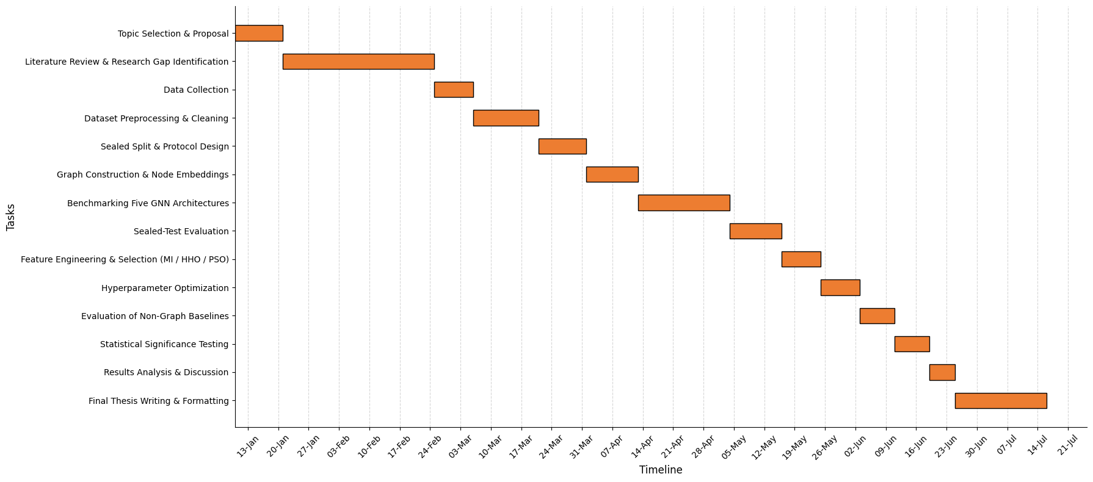
Figure 5.1 Project Gantt chart

Summary
This chapter has described the standards, constraints and milestones that guided the study. The work follows established practice for reproducible machine learning and makes it clear that medical-device standards are not applicable because the proposed framework is intended for research and is not deployed in a clinical setting. The computational requirements are modest, and the entire study was completed using freely available computing resources. Graph construction is the only part of the pipeline that would require a different approach if much larger datasets were used. The potential of the framework to improve access to PCOS screening has been considered alongside its limitations. The risks of automation bias and limited generalizability from a single cohort are acknowledged. Ethical, privacy and security concerns are also limited because the dataset is publicly available, de-identified, and the framework was developed and evaluated entirely within a notebook environment. Any additional risks would arise only if the framework were developed for clinical use. The study is bounded by several practical constraints, including the use of a single cohort, the limited size of the dataset, the absence of five endocrine assays, and the use of a single-seed, session-limited computing environment. These constraints define the scope of the conclusions and have been addressed where possible or clearly stated where they could not be avoided. The project was completed in five phases between January and July 2026. Each stage produced versioned outputs, allowing individual parts of the pipeline to be rerun without repeating the entire workflow. Progress was measured against five defined milestones, ending with the submission of the completed thesis.

Chapter 6

Conclusion

Summary of the Work Done
This thesis investigated whether PCOS can be detected from routine clinical data by representing a patient cohort as a similarity graph and applying graph neural networks to the resulting node-classification problem. The motivation is practical. PCOS is a common disorder that remains frequently undiagnosed, and definitive diagnosis typically relies on a combination of clinical, biochemical and ultrasound findings that may not all be available in resource-constrained environments. A model that operates using information already obtained during a standard gynecological assessment, including clinical history, anthropometric measurements, routine blood tests and ultrasound offer greater potential for deployment than one requiring specialized endocrine assays. The proposed framework constructs a patient-similarity graph from the 541-patient Kerala PCOS cohort by connecting each patient to her ten nearest neighbors according to cosine similarity computed on standardized clinical features. Each node is represented by the concatenation of the patient's clinical feature vector and a 64-dimensional structural embedding learned from random walks on the graph. This allows both the individual's clinical presentation and her position within the patient network to contribute to the prediction. Five graph neural network architectures (GCN, GAT, GraphSAGE, MPNN and GIN) were evaluated using this common representation. The study also examined three related questions under the same experimental framework. Those are whether feature selection improves detection performance, whether hyperparameter optimization offers an advantage over well-chosen default settings, and how the proposed graph-based representation compares with conventional tabular machine learning models. The principal contribution of this work is methodological rather than architectural. A test partition of 109 patients was sealed before any modelling decisions were made and opened only once for each reported configuration. Every data-dependent artefact, including feature scaling, graph construction, structural embedding generation, synthetic minority oversampling, feature selection and hyperparameter optimization was fitted only on the training data and regenerated independently within each cross-validation fold. An internal determinism check, in which an identical configuration was evaluated twice under different names, confirmed that the pipeline was free of hidden nondeterminism, with both executions producing identical results. Finally, every comparative claim was supported by paired statistical inference with appropriate correction for multiple comparisons rather than being based solely on differences in point estimates. The principal findings are summarized in Chapter 4. On the sealed test set, GraphSAGE detects PCOS with a MCC of 0.8110, an AUROC of 0.9486 and an accuracy of 0.9174. It correctly identifies 30 of the 36 PCOS-positive patients while producing only three false-positive predictions. Among the five graph neural network architectures, GraphSAGE achieves the strongest overall performance. After Holm correction, it significantly outperforms GIN, whose unnormalized sum aggregation leads to unstable behavior on the k-nearest-neighbor graph, where highly connected hub nodes accumulate large degrees. However, GraphSAGE is not statistically distinguishable from GCN, GAT or MPNN. Mutual information feature selection reproduces the performance of the full-feature baseline using only 20 of the original 48 predictors. Inferential analysis indicates that the observed difference is consistent with sampling variability. This demonstrates improved parsimony rather than improved predictive performance. Despite being conducted under the same conditions used for deployment and initialized with the default configuration, hyperparameter optimization does not improve upon the default settings. Instead, it reduces performance for three of the four feature subsets. Finally, the proposed framework performs competitively with Random Forest, Logistic Regression and XGBoost on the identical data partition, but no evidence of superior performance over these conventional tabular models was found.

Key Contributions
- A validated graph-based detection framework for routine clinical data. The study shows that a patient-similarity graph can be constructed from routine clinical measurements despite the absence of an inherent relational structure in the data, and that message passing over this graph supports clinically useful detection of PCOS. The proposed framework achieves an MCC of 0.8110, an AUROC of 0.9486 and a sensitivity of 0.8333 on the sealed test set while relying only on markers obtainable through a standard gynecological assessment, without the need for specialized endocrine assays.
- A systematic architectural comparison, with the differences tested. Five message-passing architectures were evaluated under an identical experimental pipeline, ensuring that any observed differences in performance were attributable to the architectures themselves rather than to differences in preprocessing or model development. GraphSAGE came out as the preferred architecture, and the study provides a detailed explanation for this result. By maintaining separate representations for a node's own features and the aggregated neighborhood information, GraphSAGE preserves the patient's individual clinical presentation while still exploiting evidence from clinically similar patients. In contrast, GIN's unnormalized sum aggregation amplifies variation in node degree, leading to unstable behavior on the patient-similarity graph.
- A leakage-controlled evaluation protocol, executed and verified. The methodological protocol developed in this study extends beyond the specific application to PCOS detection. Its principal components are readily applicable to other clinical machine learning studies. The reproducibility of the pipeline is demonstrated rather than assumed. Two independently developed notebooks reproduced the headline configuration with a maximum per-patient predicted-probability difference of only 5.4 × 10⁻⁷.
- Three negative and null results. Feature selection improves parsimony rather than predictive performance. Hyperparameter optimization with the final deployment setting, does not improve upon well-chosen default configurations on a cohort of this size. The improvements observed during inner cross-validation do not extend to the independent sealed test. The proposed graph-based framework performs competitively with strong tabular machine learning models but does not demonstrate superior performance.
- An explicit demonstration of the resolution limit of a small clinical cohort. The study establishes empirically that an MCC difference of 0.1197 between two architectures cannot be distinguished from sampling variability on a sealed test set of 109 patients. This result underscores the need for caution when interpreting small performance differences on small clinical cohorts.

Limitations of the Study
Several limitations should be considered when interpreting these findings. Some of the limitations were identified only during a post-hoc audit of the pipeline after the results had been finalized. The most important concern is statistical power. The sealed test set contains only 109 patients, including 36 positive cases. This means that the classification of a single patient changes the overall accuracy by approximately one percentage point. Moreover, the study's own analysis indicates that an MCC difference of up to 0.12 cannot be distinguished at this sample size. All reported findings are derived from a single Kerala cohort without external or prospective validation. The framework is therefore internally valid, but its generalizability to other populations remains unknown. The analysis is transductive, so the reported performance does not estimate how the models would perform on a patient who is absent from the training graph. Again, the graph-versus-tabular comparison presented in Section 4.5.5 was not evaluated using paired statistical significance testing. Finally, the cohort does not include measurements of testosterone, SHBG, DHEAS, fasting insulin or fasting glucose. This limits the study to detection using routinely available clinical markers. In addition, the public dataset does not document the labelling protocol, and the ground-truth class labels are therefore accepted as provided.

Future Work
Several extensions of this work can be done directly from the limitations of this study. The most important is external validation on an independent cohort from a different institution and population. Without this, the generalizability of the framework cannot be established. The observation that cross-validation penalizes the graph model by constructing each fold's similarity graph from a reduced patient pool suggests a testable hypothesis, which is the benefit of a patient-similarity graph should increase with cohort size as each patient's neighborhood becomes denser and more accurately estimated. Testing this hypothesis on a larger cohort can be the next step arising from the present study.

References

- H. J. Teede, C. T. Tay, J. J. E. Laven, A. Dokras, L. J. Moran, T. T. Piltonen, M. F. Costello, J. Boivin, L. M. Redman, J. A. Boyle, R. J. Norman, A. Mousa, and A. E. Joham, "Recommendations from the 2023 International Evidence-based Guideline for the Assessment and Management of Polycystic Ovary Syndrome," Journal of Clinical Endocrinology & Metabolism, vol. 108, no. 10, pp. 2447–2469, 2023.
- E. Stener-Victorin, H. Teede, R. J. Norman, R. Legro, M. O. Goodarzi, A. Dokras, J. Laven, K. Hoeger, and T. T. Piltonen, "Polycystic ovary syndrome," Nature Reviews Disease Primers, vol. 10, no. 1, Art. no. 27, 2024, doi: 10.1038/s41572-024-00511-3.
- E. L. Silva, K. J. Lane, J. J. Cheng, Z. Popp, B. D. van Loenen, B. Coull, J. E. Hart, T. James-Todd, and S. Mahalingaiah, "Polycystic Ovary Syndrome Underdiagnosis Patterns by Individual-level and Spatial Social Vulnerability Measures," Journal of Clinical Endocrinology & Metabolism, vol. 110, no. 6, pp. 1657–1666, 2025.
- S. Palomba, C. Colombo, A. Busnelli, D. Caserta, and G. Vitale, "Polycystic ovary syndrome and thyroid disorder: A comprehensive narrative review of the literature," Frontiers in Endocrinology, vol. 14, Art. no. 1251866, 2023.
- J. Zhang, Y. Zhu, J. Wang, H. Hu, Y. Jin, X. Mao, H. Zhang, Y. Ye, X. Xin, and D. Li, "Global burden and epidemiological prediction of polycystic ovary syndrome from 1990 to 2019: A systematic analysis from the Global Burden of Disease Study 2019," PLoS ONE, vol. 19, no. 7, Art. no. e0306991, 2024, doi: 10.1371/journal.pone.0306991.
- P. L. Narayanan, S. Sugumar, R. Rushendran, and C. Vellapandian, "Next-generation Approaches in Targeting Polycystic Ovarian Syndrome: Innovative Strategies," Current Medicinal Chemistry, vol. 33, pp. 57–75, 2026, doi: 10.2174/0109298673368951250404170052.
- M. Li, Z. He, L. Li, H. Shi, et al., "Intelligent detection of PCOS: A systematic review of ML/DL methods, datasets, and tools," Computational and Structural Biotechnology Journal, vol. 27, pp. 1578–1599, 2025.
- M. M. Rahman, A. Islam, F. Islam, M. Zaman, M. R. Islam, M. S. A. Sakib, and H. M. H. Babu, "Empowering early detection: A web-based machine learning approach for PCOS prediction," Informatics in Medicine Unlocked, vol. 47, Art. no. 101500, 2024, doi: 10.1016/j.imu.2024.101500.
- K. M. M. Uddin, M. T. A. Bhuiyan, M. M. Rahman, M. M. Islam, and M. A. Uddin, "Early PCOS Detection: A Comparative Analysis of Traditional and Ensemble Machine Learning Models With Advanced Feature Selection," Engineering Reports, vol. 7, Art. no. e70008, 2025, doi: 10.1002/eng2.70008.
- K. M. M. Uddin, A. Chowdhury, M. M. Rahman Druvo, M. T. Jaima, M. T. A. Bhuiyan, and M. Manowarul Islam, "Improving diagnostic accuracy for PCOS: A hybrid machine learning architecture with feature selection, data balancing, and explainable AI techniques," Results in Control and Optimization, vol. 22, Art. no. 100647, 2026, doi: 10.1016/j.rico.2025.100647.
- P. B. Patil, M. Rashmi, B. V. Natesha, and R. D. Shetty, "Explainable ensemble-based machine learning model for polycystic ovary syndrome detection using hybrid feature selection," International Journal of Information Technology, 2025, doi: 10.1007/s41870-025-03044-x.
- S.-A. Sadegh-Zadeh, A. Behforouz, M. Chaparnia, R. Sadri, A. M. Hajiyavand, P. K. Damavandi, Z. Naderi, E. Mobaser, K. Kavianpour, A. S. Mamalo, H. Abbasi, and F. Moshiri, "Advancing PCOS Diagnosis: Harnessing the Power of AI and Machine Learning for Enhanced Accuracy and Efficiency," Frontiers in Biomedical Signal Processing, vol. 1, no. 1, pp. 49–70, 2026, doi: 10.62762/FBSP.2025.529389.
- S. Reka, T. Suriya Praba, K. K. Manchala, and A. Venkateswarlu, "Comprehensive Feature-Driven PCOS Predictor: A Reinforcement Learning-Based Binary Equilibrium Optimization Approach," International Journal of Computational Intelligence Systems, vol. 18, no. 1, Art. no. 188, 2025, doi: 10.1007/s44196-025-00931-3.
- J. Hou, Y. Duan, W. Zhao, Q. Sun, and J. Wang, "AutoPCOS: A Stepwise Multimodal Intelligent Framework for Polycystic Ovary Syndrome Risk Stratification and Diagnostic Support," Frontiers in Endocrinology, vol. 17, Art. no. 1760541, 2026, doi: 10.3389/fendo.2026.1760541.
- C. Tong, Y. Wu, Z. Zhuang, and Y. Yu, "A diagnostic model for polycystic ovary syndrome based on machine learning," Scientific Reports, vol. 15, Art. no. 9821, 2025, doi: 10.1038/s41598-025-92630-4.
- C.-Y. Wang, D. Pei, C.-K. Wang, J.-C. Ke, S.-T. Lee, T.-W. Chu, and Y.-J. Liang, "Using machine learning to predict patients with polycystic ovary disease in Chinese women," Taiwanese Journal of Obstetrics & Gynecology, vol. 64, no. 1, pp. 68–75, 2025, doi: 10.1016/j.tjog.2024.09.019.
- Z. Zad, V. S. Jiang, A. T. Wolf, T. Wang, J. J. Cheng, I. C. Paschalidis, and S. Mahalingaiah, "Predicting polycystic ovary syndrome with machine learning algorithms from electronic health records," Frontiers in Endocrinology, vol. 15, Art. no. 1298628, 2024, doi: 10.3389/fendo.2024.1298628.
- S. J. Pulluparambil and S. Bhat, "Exploring the feature prioritization and data sampling of PCOS diagnosis via densely connected attention based squeeze deep learning detection model," Journal of Steroid Biochemistry and Molecular Biology, vol. 258, Art. no. 106933, 2026, doi: 10.1016/j.jsbmb.2025.106933.
- A. Smithakranthi and D. Haritha, "An automated PCOS prediction model using hybrid text and gate network model using learning approaches," International Journal of System Assurance Engineering and Management, 2026, doi: 10.1007/s13198-026-03255-3.
- E. Silambarasan, G. Nirmala, and I. Mishra, "Polycystic ovary syndrome detection using optimized SVM and DenseNet," International Journal of Information Technology, vol. 17, no. 2, pp. 1039–1047, 2025, doi: 10.1007/s41870-024-02143-y.
- M. Agirsoy and M. A. Oehlschlaeger, "A machine learning approach for non-invasive PCOS diagnosis from ultrasound and clinical features," Scientific Reports, vol. 15, Art. no. 33638, 2025, doi: 10.1038/s41598-025-10453-9.
- X. Gao, S. Zhao, Y. Du, et al., "Data-driven subtypes of polycystic ovary syndrome and their association with clinical outcomes," Nature Medicine, vol. 31, pp. 4214–4224, 2025, doi: 10.1038/s41591-025-03984-1.
- M. Dapas, F. T. J. Lin, G. N. Nadkarni, R. Sisk, R. S. Legro, M. Urbanek, et al., "Distinct subtypes of polycystic ovary syndrome with novel genetic associations: An unsupervised, phenotypic clustering analysis," PLoS Medicine, vol. 17, no. 6, Art. no. e1003132, 2020, doi: 10.1371/journal.pmed.1003132.
- K. van der Ham, L. M. E. Moolhuijsen, K. Brewer, R. Sisk, A. Dunaif, J. S. E. Laven, Y. V. Louwers, and J. A. Visser, "Clustering Identifies Subtypes With Different Phenotypic Characteristics in Women With Polycystic Ovary Syndrome," The Journal of Clinical Endocrinology & Metabolism, vol. 109, no. 12, pp. 3096–3107, 2024, doi: 10.1210/clinem/dgae298.
- K. A. Burns, A. W. Stuckey, S. G. Wilson, G. F. Watts, and B. G. A. Stuckey, "Characterization of distinct polycystic ovary syndrome subtypes by cluster and principal component analyses," Frontiers in Endocrinology, vol. 16, Art. no. 1572427, 2025, doi: 10.3389/fendo.2025.1572427.
- R. H. K. Emanuel, P. D. Docherty, H. Lunt, R. Murray, and R. E. Campbell, "Clustering polycystic ovary syndrome laboratory results extracted from a large internet forum with machine learning," Intelligence-Based Medicine, vol. 9, Art. no. 100135, 2024, doi: 10.1016/j.ibmed.2024.100135.
- J. Gilmer, S. S. Schoenholz, P. F. Riley, O. Vinyals, and G. E. Dahl, "Neural Message Passing for Quantum Chemistry," in Proc. 34th Int. Conf. Machine Learning (ICML), Sydney, Australia, vol. 70, 2017, pp. 1263–1272, doi: 10.48550/arXiv.1704.01212.
- T. N. Kipf and M. Welling, "Semi-Supervised Classification with Graph Convolutional Networks," in Proc. Int. Conf. Learning Representations (ICLR), Toulon, France, 2017, doi: 10.48550/arXiv.1609.02907.
- P. Veličković, G. Cucurull, A. Casanova, A. Romero, P. Liò, and Y. Bengio, "Graph Attention Networks," in Proc. Int. Conf. Learning Representations (ICLR), Vancouver, BC, Canada, 2018, doi: 10.48550/arXiv.1710.10903.
- W. L. Hamilton, R. Ying, and J. Leskovec, "Inductive Representation Learning on Large Graphs," in Advances in Neural Information Processing Systems (NeurIPS 30), Long Beach, CA, USA, 2017, doi: 10.48550/arXiv.1706.02216.
- K. Xu, W. Hu, J. Leskovec, and S. Jegelka, "How Powerful are Graph Neural Networks?," in Proc. Int. Conf. Learning Representations (ICLR), New Orleans, LA, USA, 2019, doi: 10.48550/arXiv.1810.00826.
- C.-T. Li, Y.-C. Tsai, C.-Y. Chen, and J. C. Liao, "Graph Neural Networks for Tabular Data Learning: A Survey with Taxonomy and Directions," ACM Computing Surveys, vol. 58, no. 1, Art. no. 3744918, 2025, doi: 10.1145/3744918.
- L. Grinsztajn, E. Oyallon, and G. Varoquaux, "Why Do Tree-Based Models Still Outperform Deep Learning on Typical Tabular Data?," in Advances in Neural Information Processing Systems, vol. 35, 2022, doi: 10.52202/068431-0037.
- H. Oss Boll, A. Amirahmadi, M. Musavian Ghazani, W. Ourique de Morais, E. Pignaton de Freitas, A. Soliman, F. Etminani, S. Byttner, and M. Recamonde-Mendoza, "Graph neural networks for clinical risk prediction based on electronic health records: A survey," Journal of Biomedical Informatics, vol. 151, Art. no. 104616, 2024, doi: 10.1016/j.jbi.2024.104616.
- H. Lu and S. Uddin, "A weighted patient network-based framework for predicting chronic diseases using graph neural networks," Scientific Reports, vol. 11, no. 1, Art. no. 22607, 2021, doi: 10.1038/s41598-021-01964-2.
- H. Oss Boll, A. Amirahmadi, A. Soliman, S. Byttner, and M. Recamonde-Mendoza, "Graph Neural Networks for Heart Failure Prediction on an EHR-Based Patient Similarity Graph," arXiv:2411.19742, 2024, doi: 10.48550/arXiv.2411.19742.
- F. Abuhantash, M. K. Abu Hantash, and A. AlShehhi, "Comorbidity-based framework for Alzheimer's disease classification using graph neural networks," Scientific Reports, vol. 14, no. 1, Art. no. 21061, 2024, doi: 10.1038/s41598-024-72321-2.
- J. Li, F. Wang, J. Pan, and Z. Wen, "Identification of Autism Spectrum Disorder With Functional Graph Discriminative Network," Frontiers in Neuroscience, vol. 15, Art. no. 729937, 2021, doi: 10.3389/fnins.2021.729937.
- H. Senthilkumar and M. Arumugam, "Integrative bioinformatics and transcriptomic analysis identifies biomarkers in Polycystic Ovary Syndrome through machine learning approach," Journal of Steroid Biochemistry and Molecular Biology, vol. 255, Art. no. 106887, 2026, doi: 10.1016/j.jsbmb.2025.106887.
- W. Chen, J. Miao, J. Chen, and J. Chen, "Development of machine learning models for diagnostic biomarker identification and immune cell infiltration analysis in PCOS," Journal of Ovarian Research, vol. 18, no. 1, Art. no. 1, 2025, doi: 10.1186/s13048-024-01583-1.
- K. Xu, S. Zhang, L. Guo, T. Liu, Y. Li, and Y. Zhang, "Interpreting the molecular and cellular landscape of PCOS through bulk transcriptomics, single-cell transcriptomics and machine learning," Journal of Ovarian Research, vol. 19, Art. no. 46, 2026, doi: 10.1186/s13048-025-01956-0.
- Y. Xu, L. Ning, R. Wang, H. Ma, H. Zhao, Y. Si, X. Li, and Q. Ren, "Integrative metabolomics and machine learning reveal the toxic mechanisms of elaidic acid in polycystic ovary syndrome," Reproductive Toxicology, vol. 141, Art. no. 109200, 2026, doi: 10.1016/j.reprotox.2026.109200.
- W. Hou, J. Dong, Y. Yao, P. Zhang, G. Zhang, P. Mou, J. Guan, and Y. Wang, "Prediction of exposure to pollutants and hormones on the risk of polycystic ovarian syndrome," Journal of Ovarian Research, vol. 19, Art. no. 117, 2026, doi: 10.1186/s13048-026-01981-7.
- S. Hanassab, J. Southern, A. V. Olabode, I. Laponogov, M. Bronstein, A. N. Comninos, T. Heinis, A. Abbara, C. Izzi-Engbeaya, K. Veselkov, and W. S. Dhillo, "Identifying nutraceutical targets to treat polycystic ovary syndrome using graph representation learning," npj Women's Health, vol. 3, Art. no. 68, 2025, doi: 10.1038/s44294-025-00117-4.
- P. Kottarathil, "Polycystic ovary syndrome (PCOS)," Kaggle, 2020. [Online]. Available: https://www.kaggle.com/datasets/prasoonkottarathil/polycystic-ovary-syndrome-pcos
- T. Mikolov, I. Sutskever, K. Chen, G. Corrado, and J. Dean, "Distributed Representations of Words and Phrases and Their Compositionality," in Advances in Neural Information Processing Systems, vol. 26, 2013, doi: 10.48550/arXiv.1310.4546.
- A. Grover and J. Leskovec, "node2vec: Scalable Feature Learning for Networks," in Proc. 22nd ACM SIGKDD Int. Conf. Knowledge Discovery and Data Mining (KDD), San Francisco, CA, USA, 2016, pp. 855–864, doi: 10.1145/2939672.2939754.
- B. Perozzi, R. Al-Rfou, and S. Skiena, "DeepWalk: Online Learning of Social Representations," in Proc. 20th ACM SIGKDD Int. Conf. Knowledge Discovery and Data Mining (KDD), New York, NY, USA, 2014, pp. 701–710, doi: 10.1145/2623330.2623732.
- N. V. Chawla, K. W. Bowyer, L. O. Hall, and W. P. Kegelmeyer, "SMOTE: Synthetic Minority Over-sampling Technique," Journal of Artificial Intelligence Research, vol. 16, pp. 321–357, 2002, doi: 10.1613/jair.953.
- T. Akiba, S. Sano, T. Yanase, T. Ohta, and M. Koyama, "Optuna: A Next-generation Hyperparameter Optimization Framework," in Proc. 25th ACM SIGKDD Int. Conf. Knowledge Discovery & Data Mining (KDD), Anchorage, AK, USA, 2019, pp. 2623–2631, doi: 10.1145/3292500.3330701.
- M. Fey and J. E. Lenssen, "Fast Graph Representation Learning with PyTorch Geometric," in Proc. Int. Conf. Learning Representations (ICLR) Workshop, New Orleans, LA, USA, 2019, doi: 10.48550/arXiv.1903.02428.

Appendix

- Provide any supplementary materials that you have used in your thesis such questionary of the interview and survey data collection, etc.

